

Bridge cameras fill a peculiar niche in the marketplace. They’re classified as point-and-shoot cameras, but if you think of point-and-shoots as cameras that can be easily slipped into one’s pocket, the [**Sony RX10 III**](http://www.bhphotovideo.com/c/product/1242612-REG/sony_dsc_rx10m3_cyber_shot_dsc_rx10_iii_digital.html) doesn’t fit the mold. Bridge cameras can also be as large and heavy as a DSLR with a kit zoom, albeit you can’t change lenses on them, and their imaging sensors are typically tiny, compared to full-frame, APS-C, or Micro Four Thirds-format camera sensors. According to what I learned in grade school, bridge cameras can be classified as a photographic oxymoron.

**[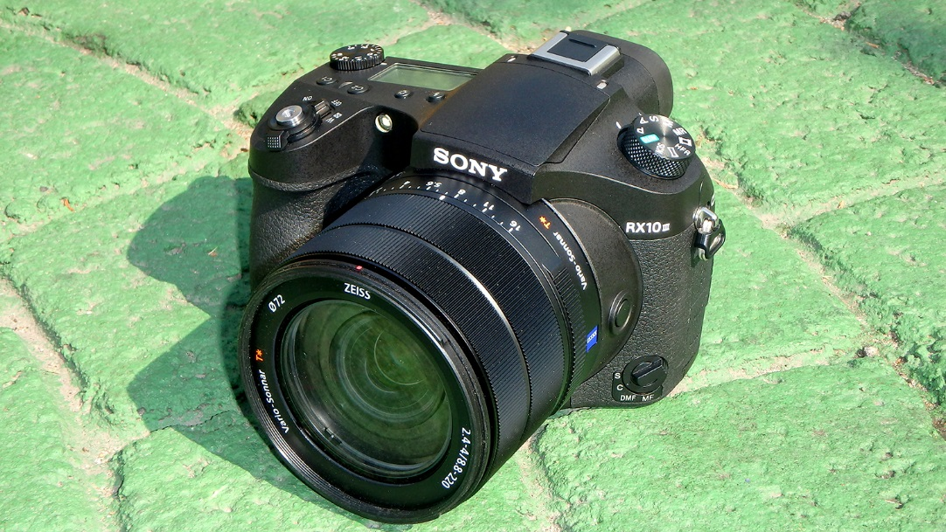](http://www.bhphotovideo.com/c/product/1242612-REG/sony_dsc_rx10m3_cyber_shot_dsc_rx10_iii_digital.html)**

The Sony RX10 III is, indeed, as large and heavy as a prosumer DSLR with a kit zoom and, yes, it contains a relatively small imaging sensor. The sensor in question, however, is Sony’s 1" 20.1MP Exmor RS BSI CMOS sensor, which is undoubtedly one of the best imaging sensors in its class. Is Sony’s RX10 III a good camera? Yup. It’s not perfect, but it’s pretty darn close!

The RX10 III is hefty. It fills the hand like a full-size camera, and its polycarbonate shell has the same solid feel as its predecessors, the Sony RX10 and RX10 II. The RX10 III features an updated back-illuminated sensor with stacked technologies; a BIONZ X image processor; dedicated DRAM chip that enables reduced noise and faster readout speeds that greatly minimize rolling shutter distortion; ISO sensitivity up to 12800; and continuous shooting up to 14 fps. Not too shabby.

On the optical front, the RX10 III sports an all-new Zeiss Vario-Sonnar 24 to 600mm equivalent f/2.4-4 T* zoom lens, which leaves little excuse for sloppily composed pictures regardless of how far or close your subject is from your camera position.

|  |  |
| --- | --- |
| [https://static.bhphotovideo.com/explora/sites/default/files/styles/960/public/_dsc0927.jpg?itok=tlPsWG4_](https://static.bhphotovideo.com/explora/sites/default/files/_dsc0927.jpg)[https://static.bhphotovideo.com/explora/sites/default/files/styles/960/public/_dsc0925.jpg?itok=-igtA4Am](https://static.bhphotovideo.com/explora/sites/default/files/_dsc0925.jpg) |  |
|  | |

​The focal range of the RX10 III’s 25x 24-600mm equivalent zoom lens is simply remarkable, as these two images clearly demonstrate.

As for image quality, it’s nice… real nice, and with a minimum focusing distance of 1.18 inches at the wide end and 2.36 feet at the telephoto end of the zoom range, you can get in-your-face close-ups of whatever you’re photographing, whether it’s five centimeters or five city blocks from where you’re standing.

|  |  |
| --- | --- |
| [https://static.bhphotovideo.com/explora/sites/default/files/styles/960/public/_dsc0966.jpg?itok=fkyc7K5f](https://static.bhphotovideo.com/explora/sites/default/files/_dsc0966.jpg) | [https://static.bhphotovideo.com/explora/sites/default/files/styles/960/public/aaa_dsc1025-editted.jpg?itok=6OluK3Ep](https://static.bhphotovideo.com/explora/sites/default/files/aaa_dsc1025-editted.jpg) |

The Sony RX10 III enables close-ups of foliage, as well as crushing traffic jams, with equal ease.

To Sony’s credit, the camera’s Optical SteadyShot Image Stabilization system performs as advertised, even at the farthest reach of the focal range. Though I heavily advocate using tripods for longer focal length lenses, I was able to capture sharp handheld photographs of subjects, both close and distant throughout the lens’s zoom range.

|  |  |
| --- | --- |
| [https://static.bhphotovideo.com/explora/sites/default/files/styles/960/public/_dsc0828.jpg?itok=zZqcxTZ3](https://static.bhphotovideo.com/explora/sites/default/files/_dsc0828.jpg) | [https://static.bhphotovideo.com/explora/sites/default/files/styles/960/public/_dsc0824.jpg?itok=eBHdgz8x](https://static.bhphotovideo.com/explora/sites/default/files/_dsc0824.jpg) |

If your needs should exceed the 8-degree angle of view afforded at the far reach of the camera’s zoom range, the RX10 III features a 2x Clear Image Zoom feature that takes you to the equivalent of a 1200mm lens without apparent loss of image quality. There’s also a 4x digital zoom option and, thanks to the image quality afforded by the camera’s very able sensor/lens combination, there’s lots of wiggle room for cropping post-capture.

There are three control rings on the lens: zoom, focus, and aperture. The aperture ring offers a choice of traditional clicks in third-stop detents, or you can flip a switch on the side of the lens for silent aperture control when shooting video.

You have two methods for zooming the lens—power and manual. The power zoom switch, which is located in front of the shutter button, is nice and smooth, especially for video capture. The manual zoom ring is located on the lens barrel between the aperture and manual focus rings, and I admittedly confused the focus and zoom controls on more than one occasion before I got accustomed to the arrangement.

|  |  |
| --- | --- |
| [https://static.bhphotovideo.com/explora/sites/default/files/styles/960/public/_dsc0895.jpg?itok=0EWcncNY](https://static.bhphotovideo.com/explora/sites/default/files/_dsc0895.jpg) | [https://static.bhphotovideo.com/explora/sites/default/files/styles/960/public/_dsc0906.jpg?itok=kbywWceM](https://static.bhphotovideo.com/explora/sites/default/files/_dsc0906.jpg) |
|  |  |

Zooming from wide to telephoto and vice versa is, in my opinion, painfully slow and awkward. If you’re used to the speed and immediacy of zooming a conventional zoom lens, you will have to learn to be patient. You’ll get there, but it will take a bit longer than you might prefer.

Though generally responsive, I have mixed feelings about the AF system in the RX10 III. While the AF system was quick when focusing between subjects within close proximity, it often turtled its way to the focus point when transitioning between close and distant subjects. To be fair, there’s an awful lot of glass to move around in this lens—18 elements (including 6 Aspherical and 8 ED elements) in 13 groups, which has to be taken into consideration. Again, I’m not referring to AF accuracy here, I’m referring to AF speed.

Shooting at ridiculously long focal lengths can be disorienting, so to make shooting at the extreme telephoto end of the zoom range easier, the RX10 III has a Zoom Assist feature that temporarily zooms the lens back to a shorter focal range, enabling you to get your visual bearings and fine-tune your composition. Release the Assist and the lens automatically snaps back to the longer focal length. If you’ve ever shot with a long telephoto lens, you’ll appreciate this feature.

[](https://static.bhphotovideo.com/explora/sites/default/files/_dsc0851.jpg)If 24mm isn’t wide enough, you can always switch the camera to Panorama mode.

The RX10 III captures UHD 4K30 video and is capable of capturing 40x slow motion Full HD 1080p video at 960 fps. 4K and Full HD video is recorded in a 100 Mbps XAVC S format, in an MP4 wrapper with 4:2:0 color sampling when recording internally, or 4:2:2 sampling when using an external recorder (optional) via HDMI output. Other video-centric features include headphone and mic ports.

If you’ve shot with a previous-generation Sony RX camera or any of Sony’s A7-series cameras, the controls and shooting menus will seem quite familiar to you. There have been subtle changes here and there, but if you sit down with the camera over a cup of coffee, you should be good to go. I should note that the things that traditionally get my goat about the menus of Sony A7-series cameras—too much scrolling—continue to do so when shooting with the RX10 III.

|  |  |
| --- | --- |
| [https://static.bhphotovideo.com/explora/sites/default/files/styles/960/public/_dsc0749.jpg?itok=gJnjoA57](https://static.bhphotovideo.com/explora/sites/default/files/_dsc0749.jpg) | [https://static.bhphotovideo.com/explora/sites/default/files/styles/960/public/_dsc0795.jpg?itok=InVk2oA5](https://static.bhphotovideo.com/explora/sites/default/files/_dsc0795.jpg) |

For composing and reviewing pictures, the RX10 III offers a choice of a 2.36m-dot OLED Tru-Finder EVF or the rear-mounted 3.0" 1.228m-dot Tilting Xtra Fine LCD, both of which are sharp, bright, and easy on the eyes.

According to Sony, you can expect to capture 370 to 420 still images or 65 to 130 minutes of video capture per battery charge, depending on whether you are using the EVF or LCD, and it takes about 150-minutes to recharge the battery when using the supplied USB in-camera charger. (Word to the wise: always carry at least one spare battery when shooting with this camera.)

|  |  |
| --- | --- |
| [https://static.bhphotovideo.com/explora/sites/default/files/styles/960/public/_dsc0715.jpg?itok=8WkVfQpb](https://static.bhphotovideo.com/explora/sites/default/files/_dsc0715.jpg) | [https://static.bhphotovideo.com/explora/sites/default/files/styles/960/public/_dsc0867.jpg?itok=U2QRjqaz](https://static.bhphotovideo.com/explora/sites/default/files/_dsc0867.jpg) |

The [**Sony DSC-RX10 III**](http://www.bhphotovideo.com/c/product/1242612-REG/sony_dsc_rx10m3_cyber_shot_dsc_rx10_iii_digital.html) accepts SD and SDHC/XC memory cards, as well as Memory Stick Duo, Pro Duo, PRO Duo (High Speed), PRO HG-Duo, Memory, Micro, and Micro (M2) memory cards. And for those who prefer going wireless when uploading stills and video, Sony’s RX10 III features built-in Wi-Fi and NFC functionality.

So, does Sony’s RX10 III cut the mustard in terms of being the perfect, only camera you’ll ever need? Well… yes, and no. It *does* capture amazingly high-quality photographs, and the focal range of the lens definitely covers all bases.

The flip side—at least for me—is that while the RX10 III has everything I wish for in an all-in-one camera, it *is* big and it *is* heavy, compared to cameras such as the Sony RX100 IV. The RX100 IV may not have the optical range of the RX10 III, but I wouldn’t think twice about carrying this smaller camera around all day.