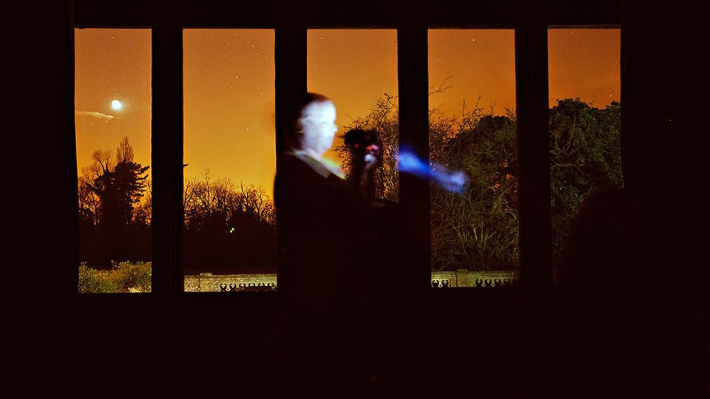

*Paranormal: Phenomena analogous to physical phenomena but with no known physical cause, as mediumistic “raps,” telekinesis, etc.* According to an article in[**the Oxford Journals**](http://nq.oxfordjournals.org/content/62/1/31.short?rss=1), the word “paranormal” was first defined, as noted above, in the 1920 revision of *Webster’s New International Dictionary of the English Language*.

While the existence of otherworldly phenomena, i.e., references to ghosts, apparitions, and other unexplainable forces, dates back to the dawn of civilization, the term paranormal and its related activities has its roots in the Victorian era, a time period that also witnessed the invention of photography and the rise of the Spiritualist movement.

Spiritualism, the belief that spirits of the dead have the ability to communicate with the living, developed and flourished from the 1840s to the 1920s, particularly in English-speaking countries.

Above photograph © Shannon Taggart

[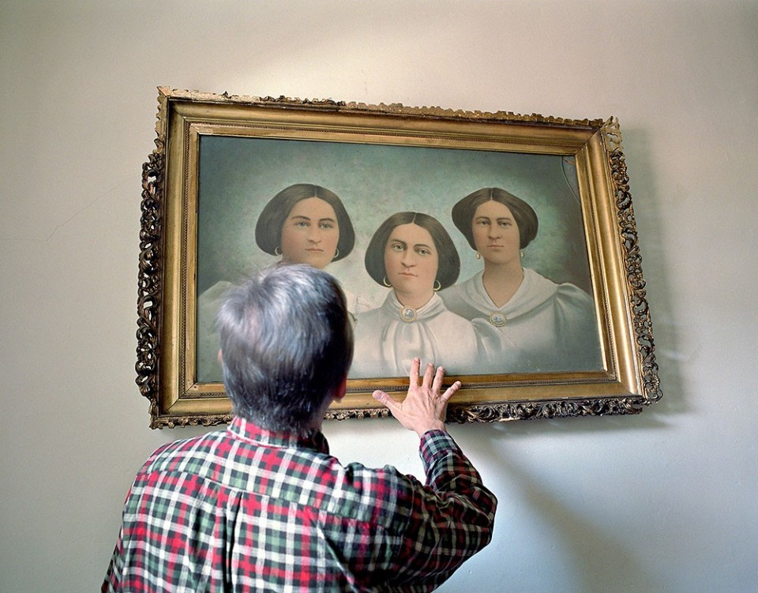](https://static.bhphotovideo.com/explora/sites/default/files/shannon_taggart_fox_sisters.jpg)Lily Dale historian Ron Nagy with painting of the Fox sisters, Margaret and Kate, the founders of Spiritualism, with their eldest sister, Leah; Lily Dale, New York*Shannon Taggart*

The American spiritualist movement had its roots in Western New York State, where it remains active to this day. There, in early 1848, two young girls—the Fox sisters—convinced their mother, and then the wider public, that nocturnal rappings heard in their rural farmhouse were communications with the spirit world. Word soon spread of this phenomenon, which gained traction due to popular theories of the time that envisioned the material world and human experience as only a reflection of a larger spiritual universe. Heated debate over the veracity of the sisters’ claims transformed them into celebrities of their day, and earned them the distinction as history’s first spiritualist mediums.

This same era was ripe with scientific inquiry steeped in the analysis of evidence, and social reforms that disrupted the status quo, and improved the status of women. Other sociological factors—from the rise of industrialization and rampant overcrowding and disease within urban centers, to the devastation of the Civil War—led to a widespread preoccupation with death among the general public.

William B. Mumler, the first spirit photographer

[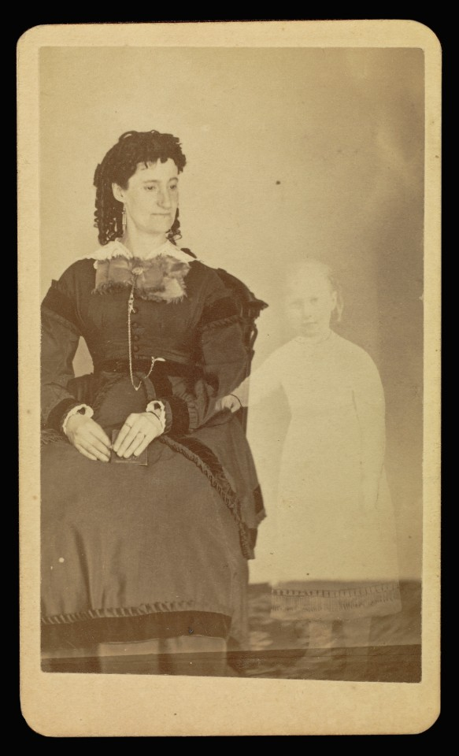](https://static.bhphotovideo.com/explora/sites/default/files/mumler_mrs_tinkham_10227101.jpg)

Mrs. Tinkham with the spirit of her child. *Photograph by William H. Mumler (1832 - 1884), Digital image courtesy of the Getty's Open Content Program*

Post mortem photography, with its ability to comfort grieving individuals, was a common practice in 19th-Century culture. Given the emotional import of such pictures at the time, it’s easy to imagine the frenzied interest that a portrait of a living soul being visited by a departed spirit would generate. Enter the first official spirit photograph, credited to the Boston-based photographer, William H. Mumler, in 1861.

Trained as a jeweler, Mumler also enjoyed experimenting with the new science of photography. His initial spirit photograph was a self-portrait that, upon development, was found to include a ghost-like presence he claimed to resemble a long-deceased cousin. This mysterious image became widely circulated, and published in such popular Spiritualist newspapers as *The Banner of Light*.

Mumler soon went into the photography business full time, opening a studio in Boston. His wife, Hannah, who had a reputation as a clairvoyant, often greeted clients on arrival and commented about the spirits surrounding them.

[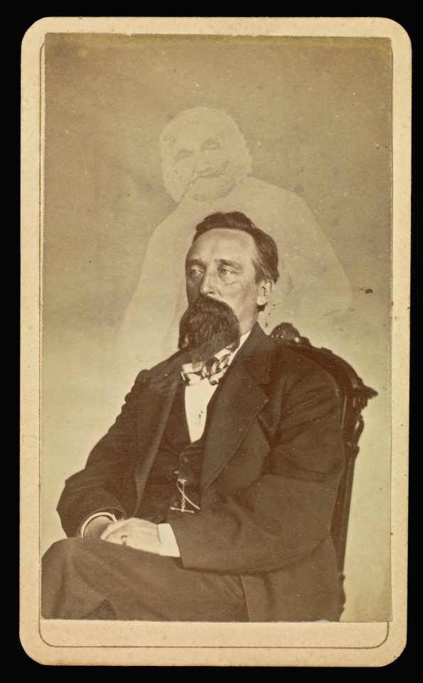](https://static.bhphotovideo.com/explora/sites/default/files/mumler_john-j.-glover-american-1862-1875_10227001.jpg)Spirit photograph of John J. Glover. *Photograph by William H. Mumler (1832 - 1884), Digital image courtesy of the Getty's Open Content Program*

At the height of his success, Mumler charged an extravagant $10 for a dozen photographs, with no guarantee that spirits would be captured. Repeated trips to his studio were often required before a sitter was blessed with a presence.

Over time, the veracity of Mumler’s spirit photographs fell into question, as some of the “spirits” they contained were said to resemble living persons. Business began to fall off, so he relocated to New York in 1868, where he regained a short-lived success.

In March, 1869, a client visited Mumler, asking for a portrait with a dead relative. After paying for a photograph that did not include the spirit he was promised, the sitter revealed himself as a New York City Marshal, working undercover as part of an elaborate police sting.

[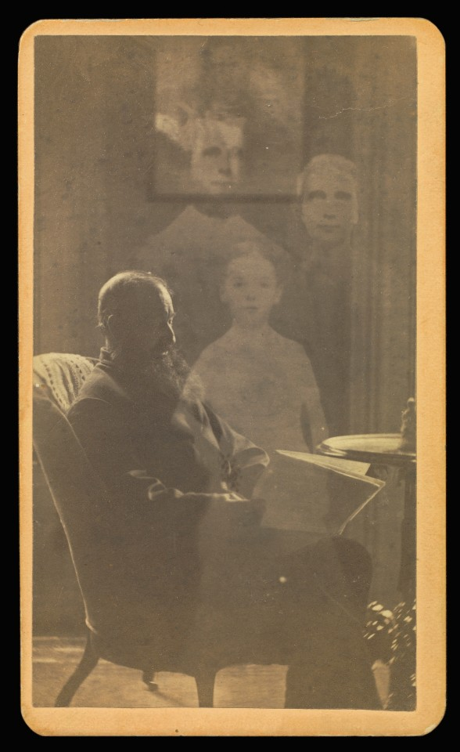](https://static.bhphotovideo.com/explora/sites/default/files/mumler_unidentified-man-with-a-long-beard-seated-with-three-spirits_1022.jpg)Unidentified man seated with three spirits. *Photograph by William H. Mumler (1832 - 1884), Digital image courtesy of the Getty's Open Content Program*

Mumler’s arrest and subsequent trial made a huge spectacle, drawing a crowd ranging from numerous spiritualist supporters to P.T. Barnum, serving as a witness for the prosecution. Although Mumler was ultimately acquitted of any crime, he returned to Boston immediately after the trial in greatly diminished circumstances.

It was there, in 1871, that Mumler made his most famous spirit photograph—a portrait of Mary Todd Lincoln with an apparition of her dead husband, the former President, standing behind her. This is believed to be the last photo taken of Mrs. Lincoln, who died in 1882. While Mumler published an autobiography in 1875, his career was in decline. By 1879 he had stopped producing spirit photographs, and he died in 1884.

[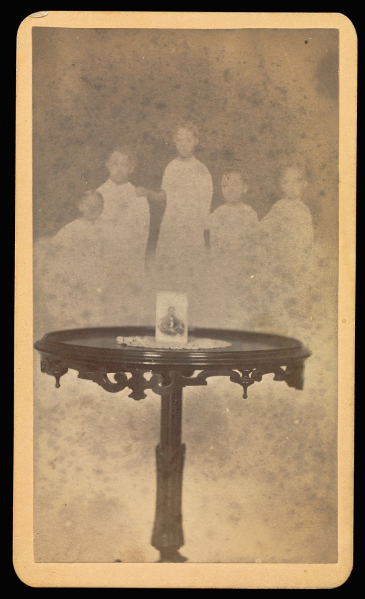](https://static.bhphotovideo.com/explora/sites/default/files/mumler_five-spirits-in-background-with-a-photograph-at-center-of-table-w.jpg)Photograph on a doily-draped table with five "spirits" behind. *Photograph by William H. Mumler (1832 - 1884), Digital image courtesy of the Getty's Open Content Program*

While there was never definitive proof that Mumler’s spirit photographs were a hoax, there were many connections to be made between his spectacular claims and entertainment forms, such as stage magic, that were in vogue during this era, as well as the spiritualist séances that were also sweeping the nation.

“It’s interesting to consider the Mumler pictures as entertainment, but also to look at them from the perspective of spiritualism,” says Shannon Taggart, a photographer who documents contemporary spiritualist practice. “There are a lot of connections between spiritualism and the beginnings of photography. Spiritualism is actually the first religion to build an iconography through photographs,” she says.

Shannon Taggart’s images of contemporary spiritualism

[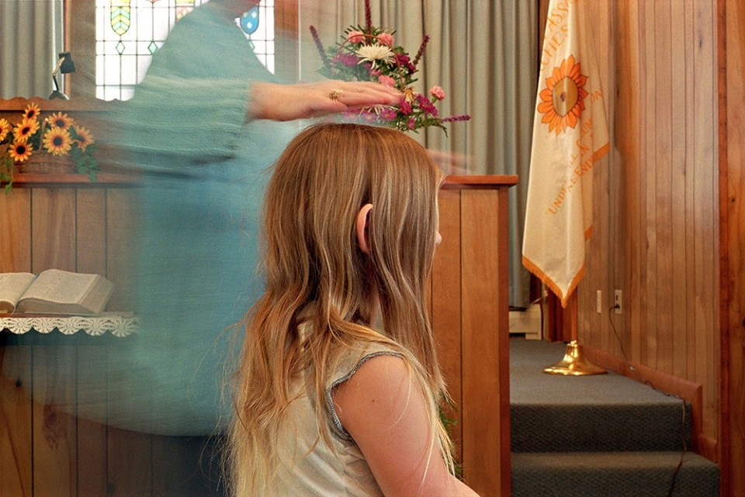](https://static.bhphotovideo.com/explora/sites/default/files/shannon_taggart_spiritualist_healing.jpg)Spiritualist Reverend Jean heals Jennifer, Lily Dale Healing Temple, Lily Dale, New York*Shannon Taggart*

Taggart began making photographs in Lily Dale, New York—the world’s largest spiritualist community—in 2001. Lily Dale, located in the same region that gave rise to the Fox sisters, was incorporated in 1879 as a Spiritualist camp and meeting place.

A century later, as Taggart was growing up in nearby Buffalo, her cousin visited a Lily Dale medium. The reading she received included a message from their grandfather with hidden details about his death, which were subsequently discovered to be true. This revelation sparked Taggart’s interest and planted the seed that would become a long-term personal project on the community. “I thought I’d spend one summer making a very straightforward project about Lily Dale, and then it turned into something else entirely,” she says.

[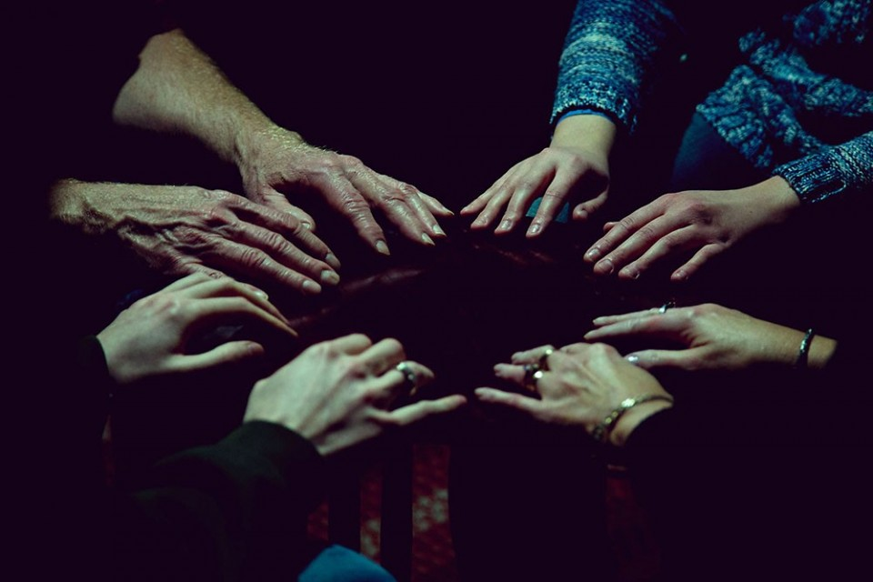](https://static.bhphotovideo.com/explora/sites/default/files/shannon_taggart_table_tipping.jpg)Table Tipping, Erie, Pennsylvania*Shannon Taggart*

“When I began the project, I could not wrap my brain around the fact that these very sane people were telling me they were speaking to dead people. But I was very curious, and the more I learned the more fascinated I became.”

Taggart immersed herself in the philosophy of Spiritualism, having readings, experiencing healings, joining in on séances. She attended a psychic college and sat in a medium’s cabinet, all with her camera. “I stumbled upon a hidden world, an abandoned system with a storied history that became a resource and an inspiration for my own photographic theory and practice,” she writes in an artist statement.

[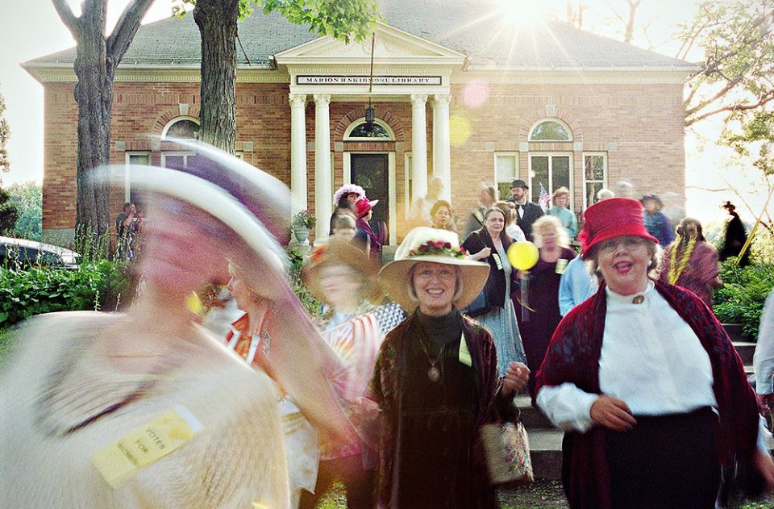](https://static.bhphotovideo.com/explora/sites/default/files/shannon_taggart_suffragettes.jpg)Suffragette Parade, Lily Dale, New York*Shannon Taggart*

In her image making, Taggart seeks to break down the standard conventions of image making and to push the boundaries of the space / time continuum with her[**Canon EOS 5D Mark III DSLR**](http://www.bhphotovideo.com/c/product/847545-REG/Canon_5260A002_EOS_5D_Mark_III.html) and a [**Canon 24 – 105 f/4 L IS USM**](http://www.bhphotovideo.com/c/product/397662-USA/Canon_0344B002AA_24_105mm_f_4L_IS_USM.html) zoom lens, “trying to be as rule-breaking and DIY as possible.”

She explains, “We use photography a lot to cling to surfaces or freeze beauty, but we forget that photography also freezes time, and condenses space, and holds the physical reflection. Photography, with its ability to freeze the reflection for eternity, is very deeply tied to mortality,” she adds. “And, throughout time, the reflection has always been viewed as mystical and magical.”

[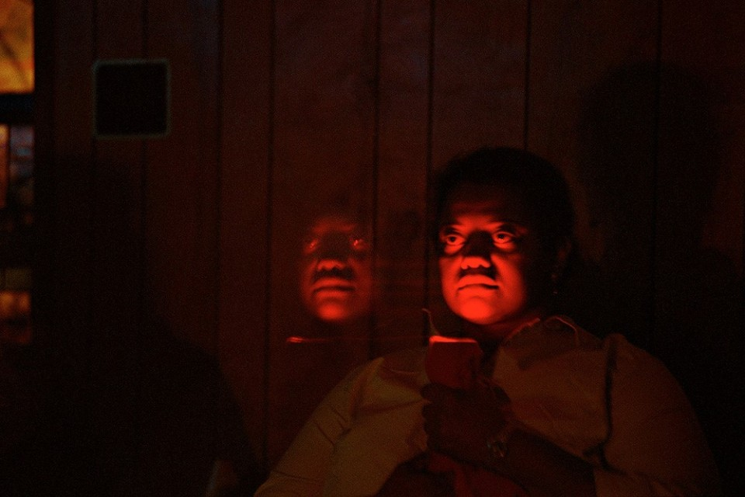](https://static.bhphotovideo.com/explora/sites/default/files/shannon_taggart_doppleganger.jpg)Woman said to be channeling her doppelgänger, Lily Dale, New York*Shannon Taggart*

Counter to a photograph’s function as a record of objective facts, Taggart’s images investigate “what’s in between the true and the false, raising questions rather than finding answers. The further I went with the project, the more interested I became in this ambiguity,” she points out. “I started to try to use the actual mechanisms of the photographic process to question these spiritual realities. To try to create photographs that could have a mechanical explanation and could also have a spiritual explanation.”

[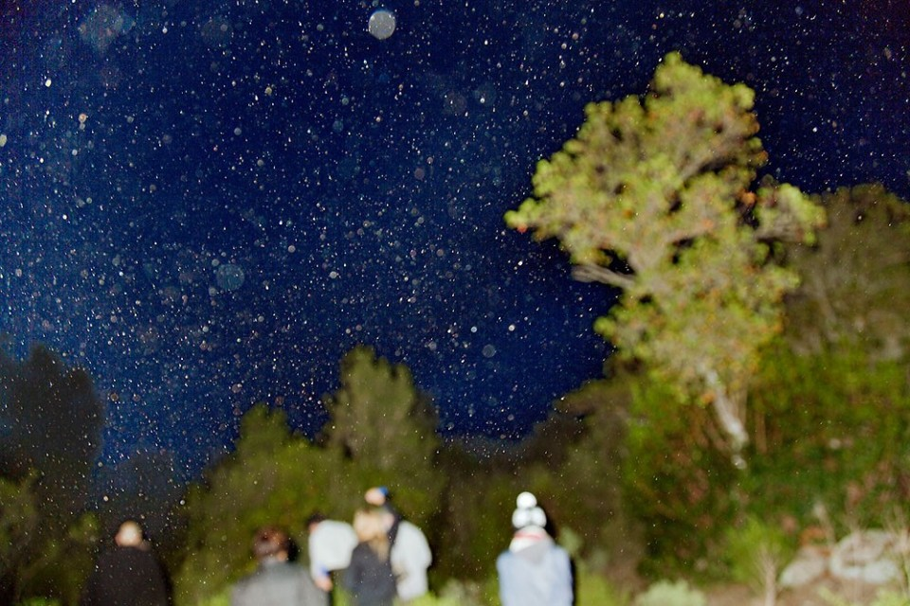](https://static.bhphotovideo.com/explora/sites/default/files/shannon_taggart_orb_hunting.jpg)Orb Hunting, Sette Fratelli Mountains, Sardinia, Italy*Shannon Taggart*

She embraces technical anomalies such as overexposure, underexposure, crazy lens flares, long exposures and the like as a means to capturing the invisible. “I try to tap into what other people have referred to as the glitch factor that exists in media, what you get when the process kind of fails.”

“Some people might find my take frustrating, because I’ve met a lot of people, both on skeptic and believer sides, who want answers,” Taggart admits. “They want something very formed, and are looking for evidence either way. I’m more interested in questioning things.”

[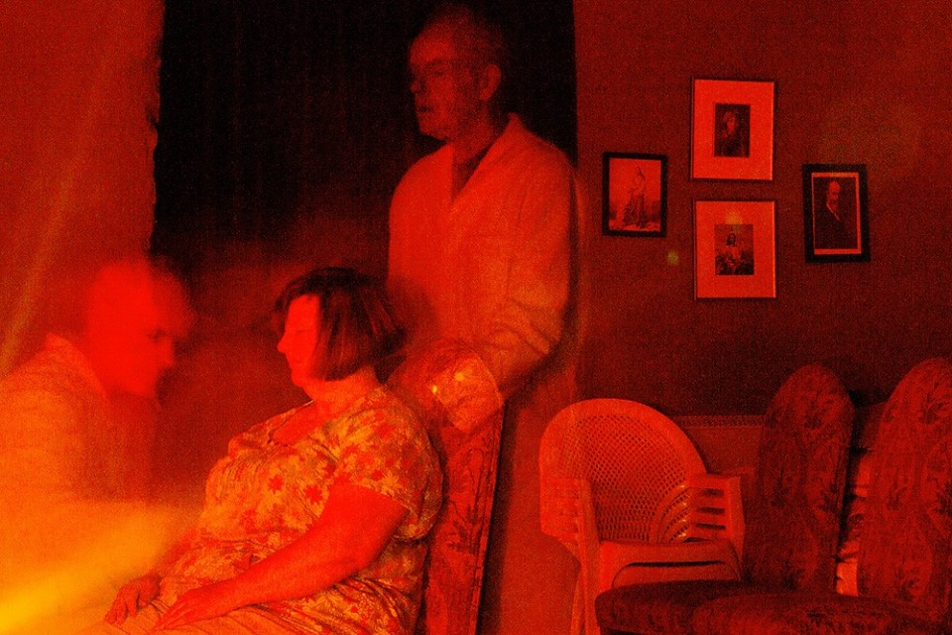](https://static.bhphotovideo.com/explora/sites/default/files/shannon_taggart_physical_mediumship.jpg)Medium conducts a spiritual healing, Montcabirol Center for Physical Mediumship, Mirepoix, France*Shannon Taggart*

An exhibition of Shannon Taggart’s photographs will be presented this summer at the 60 60 Art Gallery, in Cassadaga, New York, located just outside of Lily Dale. It will be on view through the fall. For further details on Taggart and her photography, visit [**her website**](http://www.shannontaggart.com/).