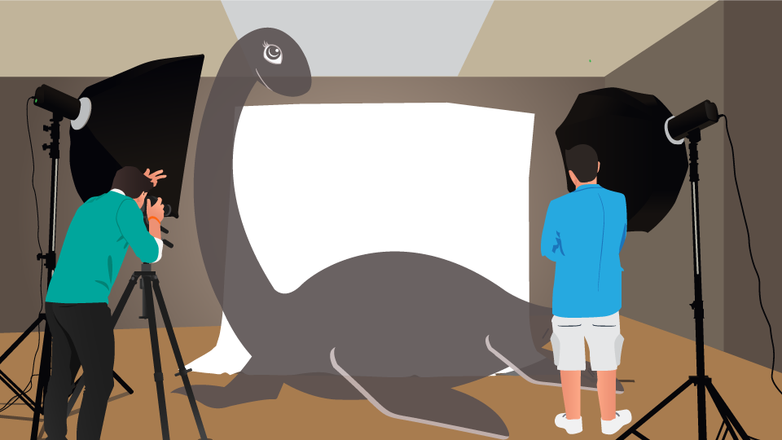

Photographing friends and family is easy. Photographing cryptids, i.e. mythical hobgoblins, boogeymen, bunyips, gremlins, ghosts, and similarly elusive creatures that lurk in forests, oceans, lakes, and outer space is another story.

Pictures exist of some of these creatures, but they’re invariably grainy, out of focus, and dubious in nature. The following creatures have never posed for formal, credible portraits. And for the record, if you can snap a decent picture of *any*of these creatures, I will buy you a box of donuts and *personally* give you a tour of the B&H SuperStore.

Bigfoot and friends

Aside from grainy pictures of some dude in an ill-fitting gorilla suit running off into the woods, nobody’s been able to photograph Bigfoot. Described as a “hairy bipedal humanoid,” Bigfoot is regarded with respect as a kindred spirit by native cultures of the northwest portion of the United States. Also known as “Sasquatch” in the Pacific Northwest, Bigfoot is also called “Chiye-tanke,” “Rugaru,” “Windago,” and “Wetiko.” Similar Bigfoot-like creatures include Yeti, who exists in Himalayan folklore, and Yowie, who prowls around the Australian Outback.

**[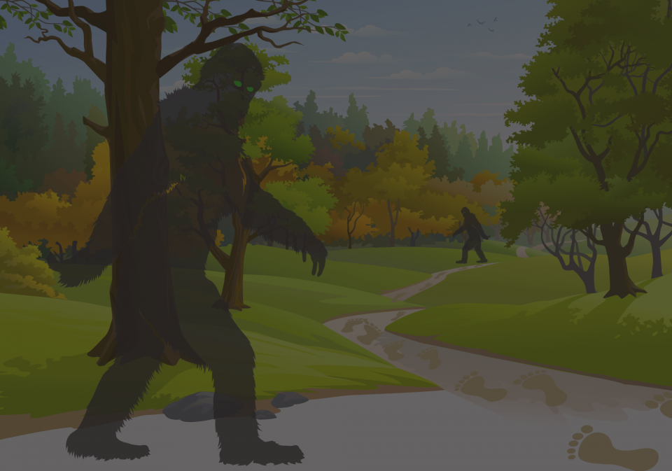](https://static.bhphotovideo.com/explora/sites/default/files/bigfoot11_0.png)**

Somewhat more menacing is Mapinguari, an 8-foot tall, scale-covered ape-like being who terrorizes the rainforests of Bolivia and Brazil. Mapinguari has long, nasty claws, red fur, and a second mouth on his/her stomach. If that’s not enough to soil your trousers, Mapinguari also has a habit of emitting a “foul-smelling scent” when feeling threatened.

Another 8-foot tall, odiferous, hairy bipedal humanoid is Momo (short for Missouri Monster), who was first spotted along the banks of the Mississippi River around 1971. Covered in fur with a pumpkin-shaped head, Momo is reportedly aggressive and, like Mapinguari, repels attackers by emitting a nasty, skunk-like odor when approached.

The Loch Ness Monster

Named after the lake it occupies in the Scottish Highlands, the Loch Ness Monster is as legendary as Scotland’s similarly legendary single-malt beverages. First sighted in the 6th century, modern sightings of “Nessie,” as he/she’s affectionately called, became more widespread when the area around the lake was built up in the 1930s. A long-necked, serpent-like creature with a broad, flat body, four flippers, and a short tail, Nessie has been spotted crossing roadways, as well as frolicking in the water. “Experts” believe Nessie is descended from Mesozoic-era plesiosaurs.

**[](https://static.bhphotovideo.com/explora/sites/default/files/nessie.jpg)**

Tessie

The Scots have “Nessie” and, in California, they have “Tessie.” A native of Lake Tahoe, Tessie is a quick-swimming snake-like creature with a long neck and a hump-like back that’s been reported on and off since the settling of the Wild West. For whatever reason, Tessie sightings are more frequent in even-numbered years. Why?  Nobody knows.

**[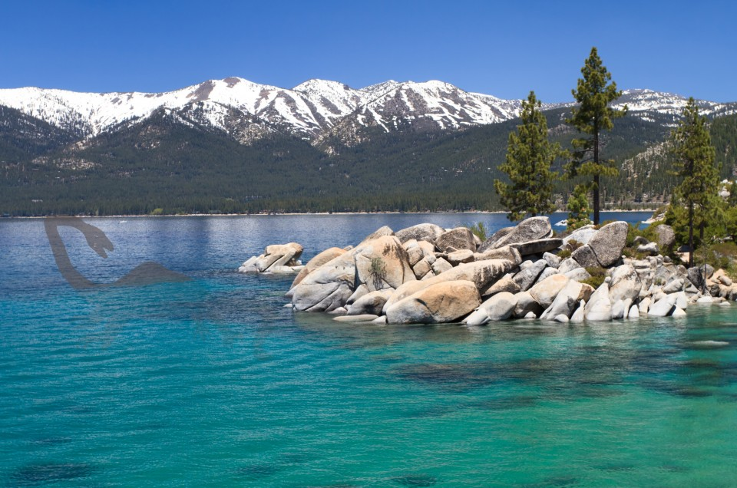](https://static.bhphotovideo.com/explora/sites/default/files/tessie.jpg)**

Dobhar-chú

Spend time around the lakes and rivers of Ireland and you might spot Dobhar-chú. Fur-covered and carnivorous with a taste for humans and dogs, the Dobhar-chú is an otter-like creature sometimes described as a mix between a beaver and a dog. Dobhar-chú hunt in packs, can supposedly outrun a horse, and are equally adept hunting on land and water.

**[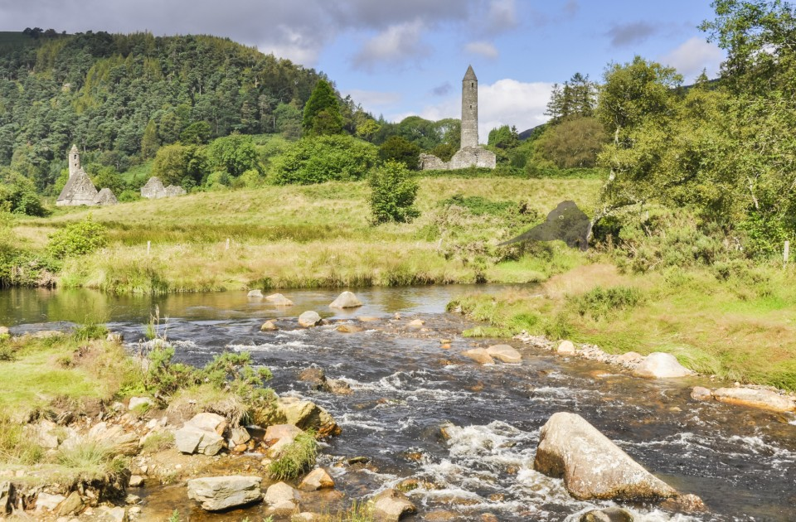](https://static.bhphotovideo.com/explora/sites/default/files/dobhar-chu.jpg)**

Altamaha-ha

Closer to home—specifically, the Altamaha River in Georgia, is Altamaha-ha, a serpent-like creature measuring 20 to 30 feet with a flat body and flippers. If the Altamaha-ha sounds similar to the Loch Ness Monster, that’s probably because the Altamaha countryside was originally settled back in the early 1700s by Scots Highlanders who, in addition to single-malt scotch, apparently brought along a wee dram of local legend.

**[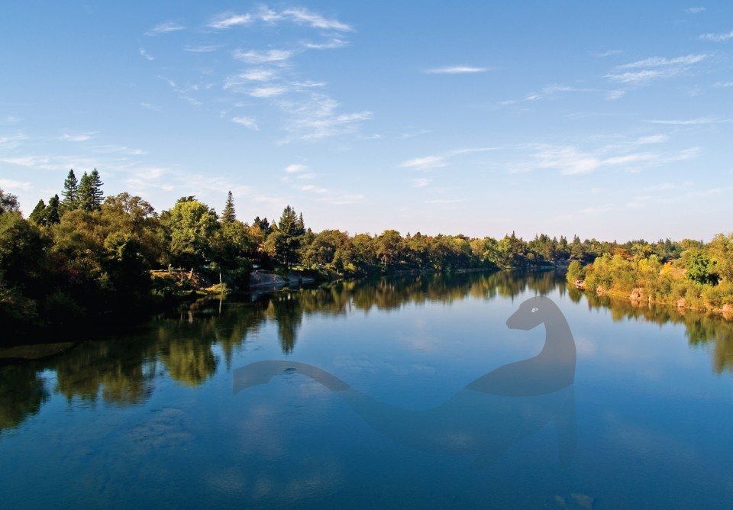](https://static.bhphotovideo.com/explora/sites/default/files/altamaha-ha.jpg)**

Akkorokamui

Hokkaido, the second largest island in Japan, is the home of a huge octopus-like creature called the **[Akkorokamui](http://cryptomundo.com/cryptozoo-news/akkorokamui/" \t "_blank)**. Large and round with big threatening eyes, the most threatening aspect of this beast is the dark, noxious-smelling fluid it emits when feeling threatened. Though numerous sightings have been made of this beast over the years, people have smelled it but never photographed it.

**[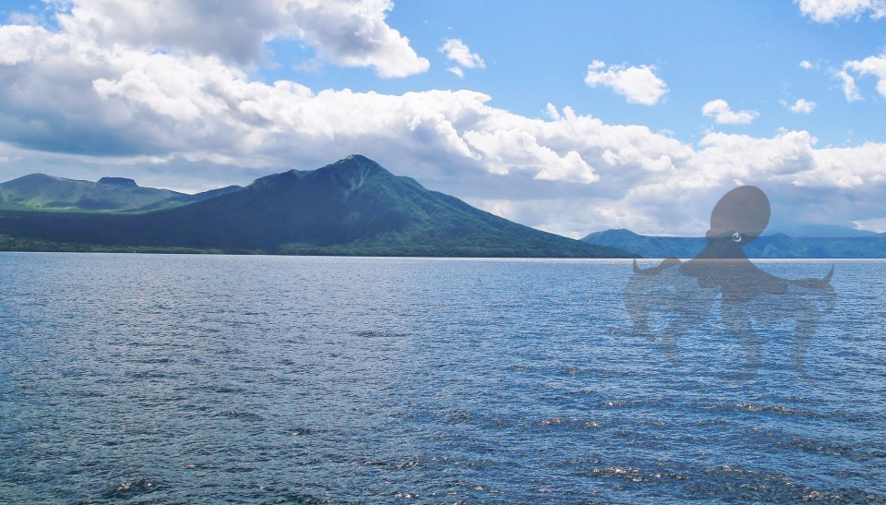](https://static.bhphotovideo.com/explora/sites/default/files/akkorokamui.jpg)**

To Filiko Teras

Most likely inspired by the sea monster that attacked Odysseus’s boat in the legendary Greek story ‘The Odyssey’, To Filiko Teras, which is Greek for ‘the friendly monster’, has a reputation not for killing people, but for messing around with their fishing boats. A native of the waters off the coast of Cape Greco National Park in Cyprus, To Filiko Teras has never been caught or photographed. Experts in these matters agree To Filiko Teras is most likely a large squid or octopus.

**[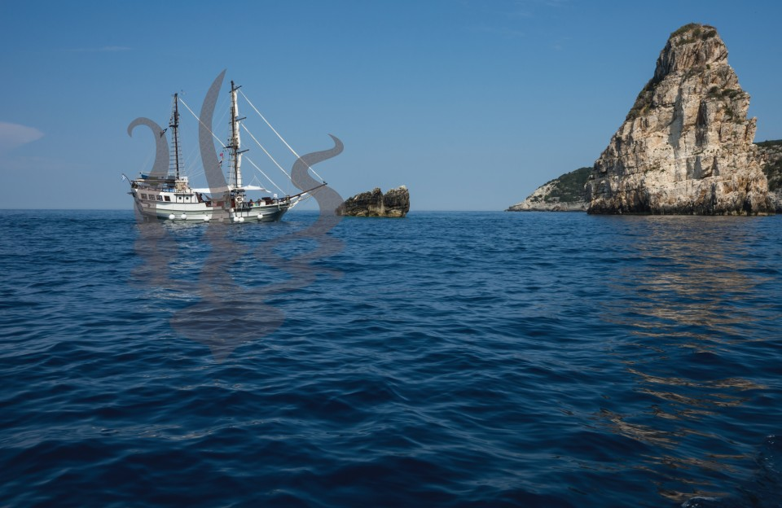](https://static.bhphotovideo.com/explora/sites/default/files/to-filiko-teras.jpg)**

Emela-ntouka

Somewhere in the swamps of Central Africa’s Congo Basin lives a large, semi-aquatic beast called the Emela-ntouka. Though herbivorous, this large, hippopotamus-like creature has a hippopotamus-like horn coming out of its head and has been known to kill animals larger than itself when disturbed. In case you’re curious, Emela-ntouka means “elephant killer” in the local dialect, so approach it slowly and be polite if you find one.

**[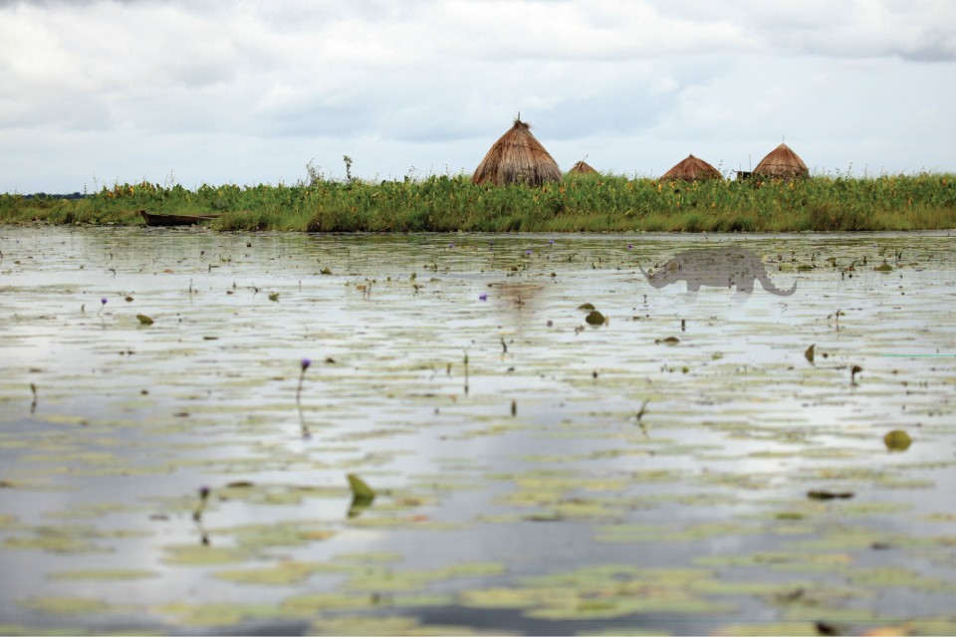](https://static.bhphotovideo.com/explora/sites/default/files/emela_update.jpg)**

Grootslang

If you find yourself in the desert region of Northwestern South Africa, keep your eyes open for the Grootslang (aka great snake) a snake-like beast with the head of an elephant with large tusks. Though supposedly destroyed around the time of the Earth’s creation, a few individuals apparently hightailed it to caves in the Northern Cape Province, where they dwell to this day. Most likely large pythons, rumors are they still exist.

**[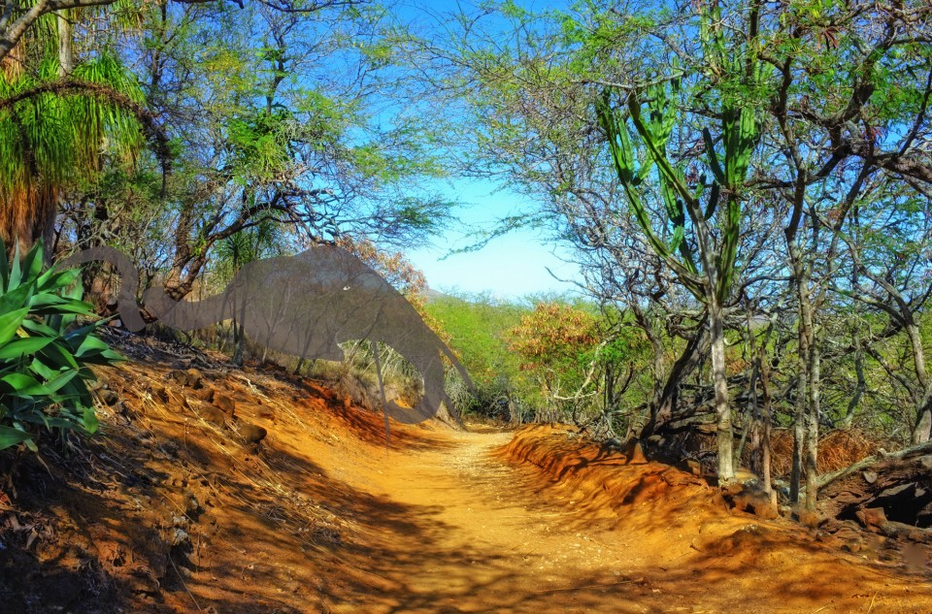](https://static.bhphotovideo.com/explora/sites/default/files/groostlang.jpg)**

Ahools

If bats creep you out you’re not going to like Ahools. Natives of the rainforests of Indonesia, Ahools are carnivorous bat-like creatures with 10-foot wingspans and powerful clawed legs that can reportedly snatch large animals—including humans—and whisk them away for lunch. Usually dismissed as being large owls, hawks, eagles, or other birds of prey, there are those who believe Ahools are actually descendants of Pterosaurs, a prehistoric family of flying dinosaurs.

**[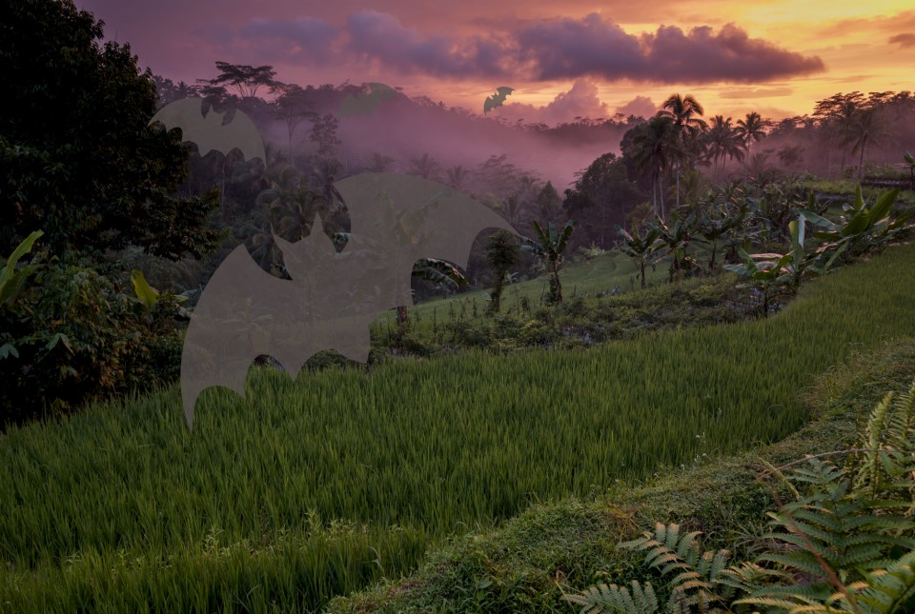](https://static.bhphotovideo.com/explora/sites/default/files/ahools.jpg)**

Olgoi-khorkkoi

Also known as the “Mongolian death worm,” these four-foot earthworms live beneath the sands of the Gobi Desert. Rumored for centuries, Olgoi-khorkkois can supposedly shoot acid from their mouths and are covered with a slime that’s fatal to the touch. They reportedly come above ground in warmer weather or when the sand gets too wet for their liking. A hazmat suit and a Super-Soaker are recommended if you plan on stalking these charming upsized worms.

**[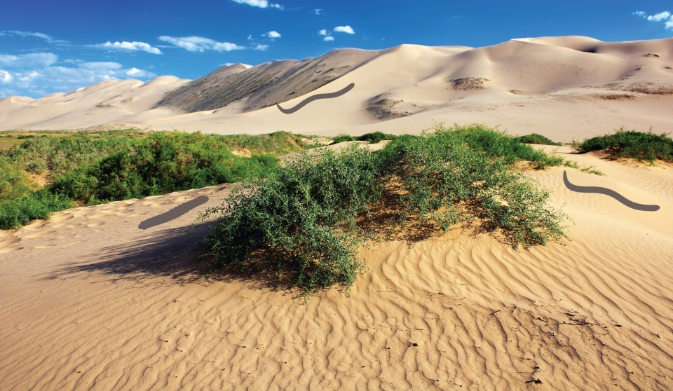](https://static.bhphotovideo.com/explora/sites/default/files/olgoi-khorkkoi.jpg)**

Tatzelwurms

In Germany they’re called Tatzelwurms. Also known as Basilicos in Italy, Arassas in France, and Bergstutzens in Switzerland, Tatzelwurms are two- to five-feet-long lizard-like creatures with cat-like heads, short, long-clawed forearms, and tapered, limbless snake-like tails. They’ve been spotted all around the Alps as recently as 2009. Though never photographed, they reportedly go well with red wine.

**[](https://static.bhphotovideo.com/explora/sites/default/files/tatzelwurms.jpg)**

Aliens

Hokey pictures of skinny green men with big heads and even bigger eyes have been making the rounds ever since a pilot named Kenneth Arnold first reported “strange objects” flying in the skies over Washington, in 1947. Some people claim to have been abducted by aliens. Some people claim my boss is an alien, but that’s a story for another day…

**[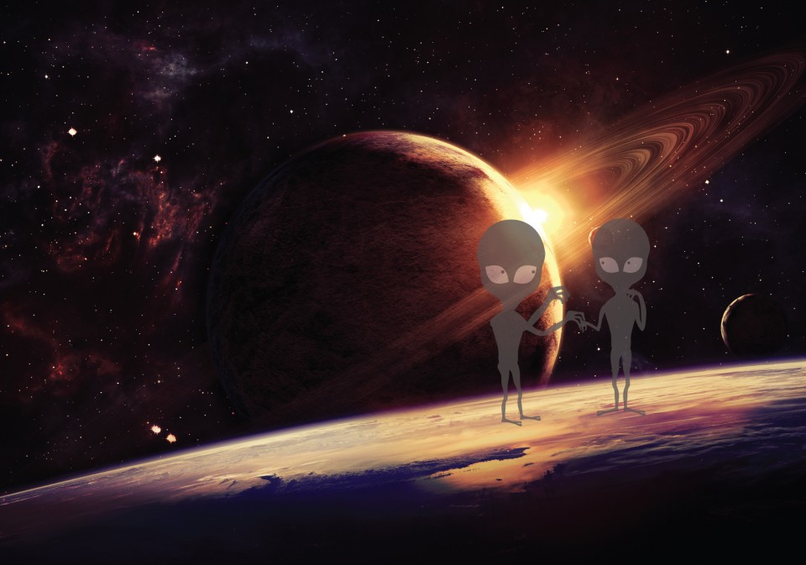](https://static.bhphotovideo.com/explora/sites/default/files/aliens.jpg)**

As for evidence, all we have are droves of photographs of dubious origin to go by... and that’s *before* Photoshop became part of our vernacular.

China just built a radio telescope the size of 30 soccer fields that might someday offer clues as to whether or not aliens really exist, but until that time we’ll have to rely on our imaginations and B movies from Hollywood.

Happy hunting!

Have you ever photographed any of these elusive creatures, or others? Tell us about it in the Comments section, below!