My Account/My info changes

Short term fixes

1. Remove photo and move info up
2. Orders on the my info page at the to nest similar items together
3. Account details should be field inputs that change when typed into with a confirmation when done
4. Change billing and shipping to be like orders
5. Default shipping address
6. Simplify titles – manage my addresses to addresses
7. My account log in should have an option for guest
8. Better confirmation of changes to my account – credit card is deleted, should be prompted to add another if there is none with a pop up screen.
9. Credit cards should be editable beyond expiration and the user should be able to add credit cards.
10. Remove “Links”
11. Rearrange the order to match the menu on the side
12. Change country from drop down to auto fill
13. Entering zip code should auto detect address

Long Term Fixes

1. Change to Icon based Dashboard and card view
2. Username all as one line
3. The ability to choose between email and text notifications

Why do we have a pop up window for login rather than just take them to the page with all the options.

Account Overview

Order notifications

Most important thing is to have the orders on top

Orders

Profile

Billing and Shipping/ shipping accounts

Payment Options-Gift Cards

Email

Wish lists

Discussions

Events

Tax ID

Software Downloads

Email management and text notifications

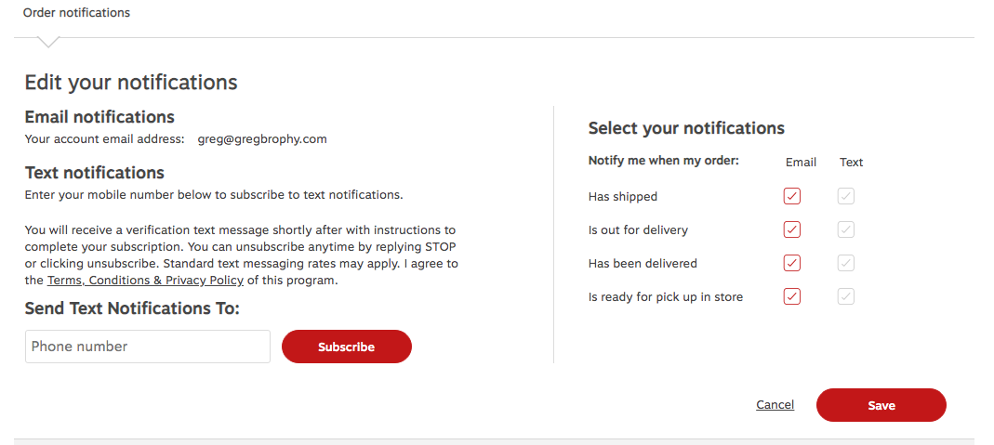

Card View Dashboard with Icons

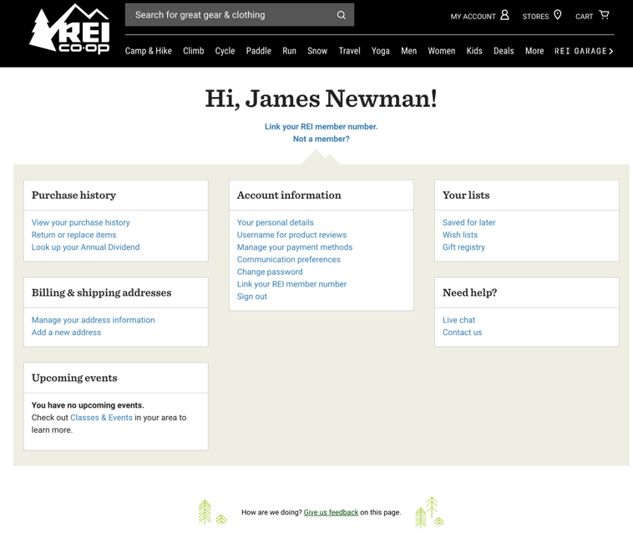

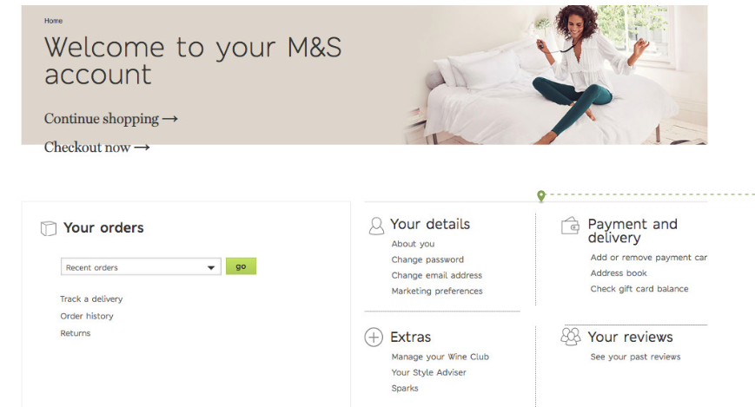

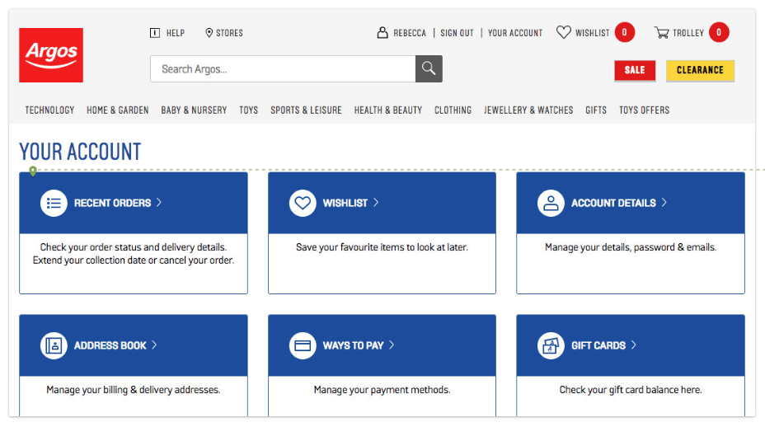

Soft Sign in

Add text to the partially signed in person on the login screen that lets them know that they are not fully signed in and if they want to use all the features, they need to sign in rather than a regular sign in screen.

