R4 Landing page

# Interaction Logic

*Provided by Yossi Beenstock:*

## Overview

In addition to the current B&H financing card, we have developed a second card which offers customers a unique rewards proposition: The Payboo card which offers a rebate on the tax paid. See eligibility

Since this is an entirely separate program, customers will need to fill a separate application form for the Payboo card. Current B&H credit card holders have ONLY the financing card. The financing card cannot be converted to a Payboo card.

Because the benefit is a refund on the tax paid, and not an order discount, the benefit is added after the total and is referred to as a card savings, not a discount.

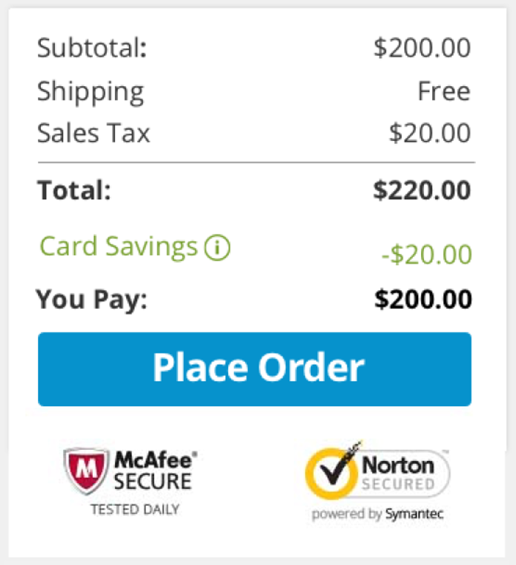

The issue with offering such a savings is:

* Certain states have restriction on what language may and may not be used in conjunction with offering tax discounts. Some states do not allow the use of any language that implies or infers that the customer will be relieved of their sales tax obligation.
* We are not currently collecting sales tax in all states

Because of this, we divided all the states into one of 3 groups: Green States, Red States and Gray States. Within the Gray Group there are 3 sub-groups, which for the most part are treated the same.

|  |  |
| --- | --- |
| **Green States** | **Red States** |
| We collect tax and **can** advertise a savings on tax | We collect tax and can **NOT** advertise a savings on tax |
| *(17) CA, HI, IL, LA, MD, MI, MN, MS, NC, NJ, NY, OK, SC, SD, UT, WA, WI* | *(13) AL, CT, DC, IA, IN, KY, ME, ND, NE, NV, VT, WV, WY* |

|  |  |  |
| --- | --- | --- |
| **Gray States** | | |
| **Group *a*** | **Group *b*** | **Group *c*** |
| States that do not collect Sales Tax | States not yet collecting Sales tax but would be able to advertise if/when they start collecting | States not yet collecting Sales tax but would **NOT** be able to advertise if/when they start collecting |
| *(5) AK, DE, MT, NH, PR* | *(8) AR, AZ, GA, MA, MO, NM, OH, TN* | *(8) CO, FL, ID, KS, PA, RI, TX, VA* |

While the card savings will always be equal to the amount of tax paid, the difference between the 3 groups is what banners they will see while browsing our website and how we advertise the special benefit.

|  |  |
| --- | --- |
| Green States | ***“SAVE THE TAX”*** |
| Red States | ***“SAVE INSTANTLY”*** |
| Gray States | ***“SPECIAL FINANCING”*** |

**How do we identify which banners to show to customers and when?**

There are many ways to identify from where a customer is, but since the restrictions are based on where the customer is shipping to, and not where they are located, the website will display banners based on the following criteria, in the following order:

1. If the customer manually enters a ship-to zip code (either in the shipping tab global banner, or in the shipping address field during checkout), the banners will be updated to be relevant to that zip-code.
2. If the customer did not manually enter a zip-code but *is* logged in, the banners displayed will be based on the most recent ship-to address
3. If the neither of the above, we display banners based on the customers location (IP address)
4. And finally, if we cannot determine any location at all, the customers will see banners for *“Red States”* – no matter where they are from

**How does a customer know how much savings they will receive?**

The customer will be able to check how much potential savings they can receive from many places around our website.

Because the savings amount is dependent on where the order is being shipped, the most accurate place would be during the check out process. However, the customer may click on the *“Learn More”* on the Payboo card banner and would be taken to lading page from where they can check their savings.

From this landing page*, they will be able to enter their zip-code to see potential savings. No matter on which version of the landing page you’re on, you can enter any zip code from any group of states, and depending on what zip is entered, customers will receive one of 3 responses

***\*This is only available from Green and Red State versions of the Payboo card landing page and not the financing card landing page***

|  |  |
| --- | --- |
| **Green and Red States** |  |
| **Gray State – Groups *a* and *b*** |  |
| **Gray States – Group *c*** |  |

**Is every purchase eligible for the Payboo card benefit?**

For the most part, customers will always receive the Payboo card benefit on their purchase, however, there are a few exceptions:

1. Since the benefit is a savings on the tax, only taxable items qualify. In addition, tax-exempt customers do not qualify.
2. If a customer splits payment with any other payment method **except** a B&H rewards card, they forgo the entire benefit. If a customer *does* add a split payment, they’ll get a pop-up warning them of this.

## UNIX

The B&H Payboo Card is identified in UNIX as BHBC (the financing card is BHFC) and since the benefit is *post* order total, the benefit is displayed as a payment line identified as “BEN”

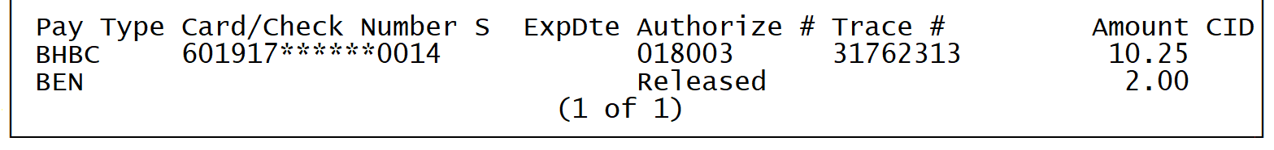

When making an order with the BHBC and the order qualifies, a pop-up will be displayed after the credit card number is entered letting you know how much of a benefit was applied

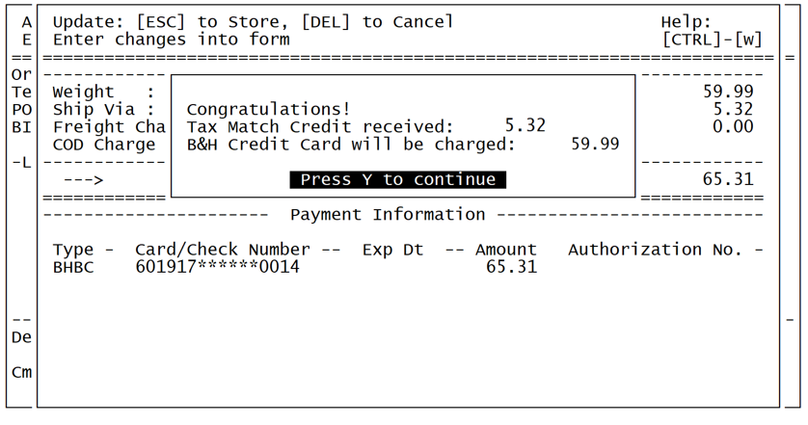

**Virtual Returns and MO Swaps**

Since the benefit of a tax savings is tied to a specific payment method, when creating a Virtual return or MO Swap, the new order will not have the Payboo Card benefit. The reason for this is because the system converts the refund to a Store Credit and applies *that* as payment on the new order.

It’s very important when creating a Virtual Return or MO Swap to provide some sort of discount to balance out the total.

There will hopefully be a fix for this, but not for launch

## FAQ’s

Q: If a customer is from a “gray” state, can they apply for the card?

A: Yes. If they are on the Payboo card landing page, they will be able to apply for the card.

Q: Will a customer still receive 2/4% rewards if the item is eligible?

A: Yes. The Payboo card benefit is separate from our current regards program.

Q: If I entered BHFC instead of BHBC do I need to enter the correct B&H credit card type?

A: No. The system will automatically identify which version of the B&H credit card has been entered. The same is true of our website.

# Links on page

**Check Savings (and both links in legal text)** – interactive modal (Zip code field)

**Apply Now** – link similar to R0 (<https://etail.mysynchrony.com/eapply/eapply.action?uniqueId=18B2DAB5A8D6B6F3259DEE3522C0964801D9E2AF72F1DFE7&client=B&H>) will be provided by Synchrony

**Log In (both links) -** <https://www.mysynchrony.com/mysyf/cmp-index.html?intcmp=na-pagena-csp-csp-internal&market=electronics&store=bhphoto>

**See All B&H Payment Options -** <https://www.bhphotovideo.com/find/HelpCenter/Payments.jsp>

URLs

## R4 Pages

Marketing to Green States **– Main / Default URL**:  
<https://www.bhphotovideo.com/credit-cards/payboo-save-the-tax>

Marketing to Red States:  
<https://www.bhphotovideo.com/credit-cards/payboo-save-instantly>

## Current Page (R0) URL

<https://www.bhphotovideo.com/credit-cards/financing>

# SEO

## Blocking Search Bots

The following code should be added to the Red state URL (<https://www.bhphotovideo.com/credit-cards/payboo-save-instantly>):

<meta name="robots" content="noindex, nofollow, noarchive">

## Redirect Rules

**Stop** redirecting <https://www.bhphotovideo.com/credit-card/> to: <https://www.bhphotovideo.com/l/credit-card/>

All scenarios below apply to **http, https, www, static, secure, non-www, with and without “/” at the end of the URLs below:**

**Start** 301 redirect <https://www.bhphotovideo.com/credit-card/>  
to: <https://www.bhphotovideo.com/credit-cards/payboo-save-the-tax>

**Start** 301 redirect <https://www.bhphotovideo.com/l/credit-card/>  
to: <https://www.bhphotovideo.com/credit-cards/payboo-save-the-tax>

**Start** 301 redirect <https://www.bhphotovideo.com/credit-cards>/  
to: <https://www.bhphotovideo.com/credit-cards/payboo-save-the-tax>

# Canonical

Please Generate Canonical URLs to itself

# Page Title

### Current

change from "B&H Credit Card" to

**B&H Photo Credit Card | Special Financing Credit Card at B&H**

### Green

**B&H Photo Credit Card | Payboo & Save the Tax**

### Red

**B&H Photo Credit Card | Save Instantly with Payboo**

# Meta Descriptions

## Green

B&H Photo's Payboo Credit Card can save you the equivalent of the sales tax paid on every purchase shipped to eligible states.

### Red

The Payboo Credit Card from B&H Photo can help qualifying cardholders save instantly, every day, on almost every purchase.

Any SEO questions please contact Moshe Rosen