B&H Community Pages

**B&H Goals**

1. Improve customer relationships
2. Have users create content on our site   
   (Reviews, Q&A and Collections, wish lists, stories)
3. Create brand awareness
4. Help show the diverse range of products we carry
5. Speak to customers in places they actually are
6. Get accurate and timely feed back from our customers

**Why (Customer Goals)**

1. A tool to educate
2. Enjoyment, being with a like minded community
3. Social credibility
4. Help Financially (Besides being a place for a all-in-one public profile, the owner of the profile pages will get incentives from every purchase made through their page (either like affiliates or B&H credits)

**Who**

1. Professionals
2. Prosumers - Hobbyists
3. Students
4. Basic or first time customers

**How**

1. Profile page with everything in one place where the user can customize –Newsfeed, friends, messages and most of what is listed below. Similar to [Google Cards](https://www.google.com/landing/now/)
2. Discussions (user discussions, reviews, Q&A)
3. B&H Content (Explora, video, Event Space)
4. Education Portal (Edu library of video courses like [Lynda.com](http://www.lynda.com/), groups of articles based on topics)
5. Gallery (memory type photos)
6. News Feed (flow type photos)
7. Gamification (like [Stack Overflow](http://stackoverflow.com/)) For instance points to finish profile
8. Wish lists (Public, private, collaborate)
9. Collections (featured collections of wedding gear for beginners by Scott Kelbey)
10. Storylines ([Medium](https://medium.com/), [Exposure](https://exposure.co/), [Time Lightbox](http://time.com/lightbox/) and [Lens Blog](http://lens.blogs.nytimes.com/?_r=0))
11. Product Sponsored BH Photo products integrated into feeds of influencers (give a camera to Gregory Hiesler and let him tweet about it. Samsung is doing this now)
12. My gear (or what I bought)
13. Reward good users/customers
14. Make Event Space more interactive (Like [Creative Live](https://www.creativelive.com/))
15. Crowdsource funding for projects – Users can create a wish list and have people contribute to the funding of it.
16. Pro Talk, a Q&A session live with professionals where people ask questions on Twitter
17. Photo of the week where the winner can be rewarded.
18. Videos centrally located on one page

B&H Community Pages

The Customers Private Profile page

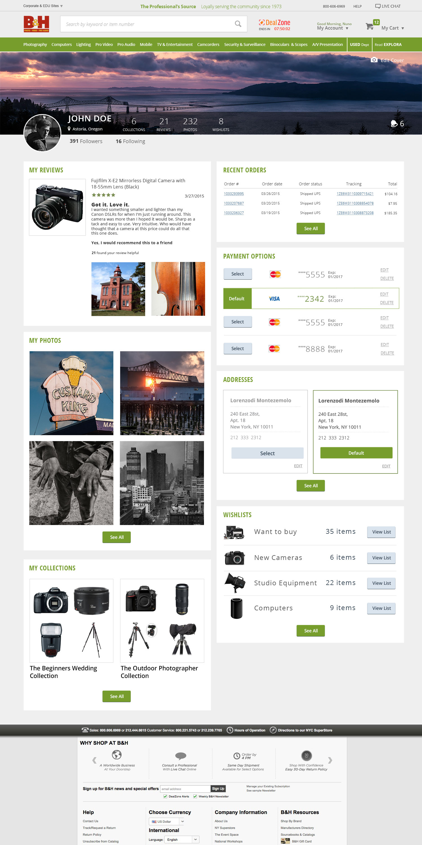

B&H Community Pages

The Main Experts Page

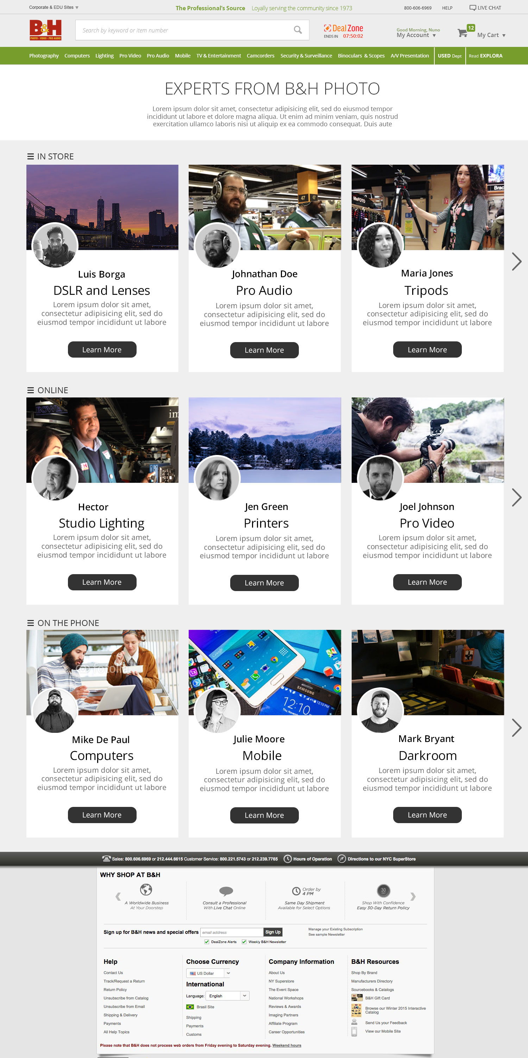

B&H Community Pages

The Expert Profile Page

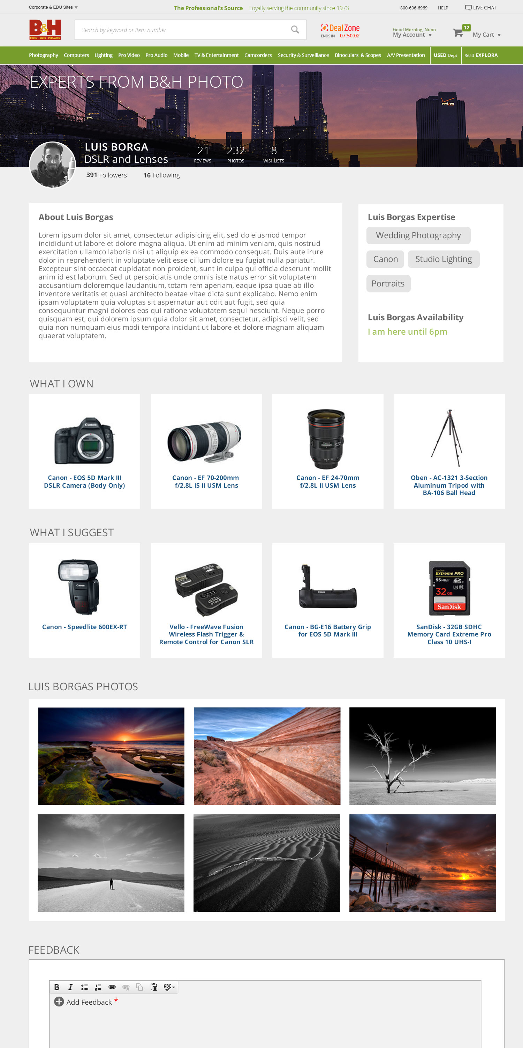

B&H Community Pages

An Example of the Experts Project Integrated into the site

