#### Introduction

The following is a heuristic review of the B&H site conducted with the aim of identifying specific issues to address. I went through a use case that would mimic what I think the user, John, would do based on the persona I created. This is done based on my personal knowledge and beliefs and not on any research of studies of our customers. I'll document my reaction in a "think out loud" format (in *italics*) and, then when finished, format the problems and recommendations in condensed document.

# Use Case: Buy a Camera Bag Persona: **John** “I have an idea of what I want but I want to make sure I get something that is good. I want a camera bag that does not look like a camera bag”

**Key Goals**

* Knows what he wants but wants to know what is available
* Wants something that is good quality
* Something that will last a long time
* Easy to clean
* Get something that looks nice but is aslo functional and not too heavy

**Behaviors**

* Gets distracted easily
* Easily influenced by reviews
* Likes to do lots of research
* Doesn’t mind spending much if it is good quality

**We Must**

* Clearly show images of the product and key features
* Make reviews easy to find and read
* Show lots of products but in an easy sort able way
* Give advice on what he is looking for
* Provide accurate information

**We Must Not**

* Load the page with irrelevant products or information
* Push cheap or inferior quality products
* Obscure product information or photos

## [InDepth Page](http://www.bhphotovideo.com/indepth/photography/hands-reviews/holiday-2012-fashionable-camera-bags)

*I went to the homepage and clicked on Photo Accessories which brought me to the Photography page. I clicked on Bags and Cases. I noticed the side bar with B&H in Depth, the link Holiday 2012: Fashionable Camera bags. I click on the link and it brings me to a blog post about camera bags.*

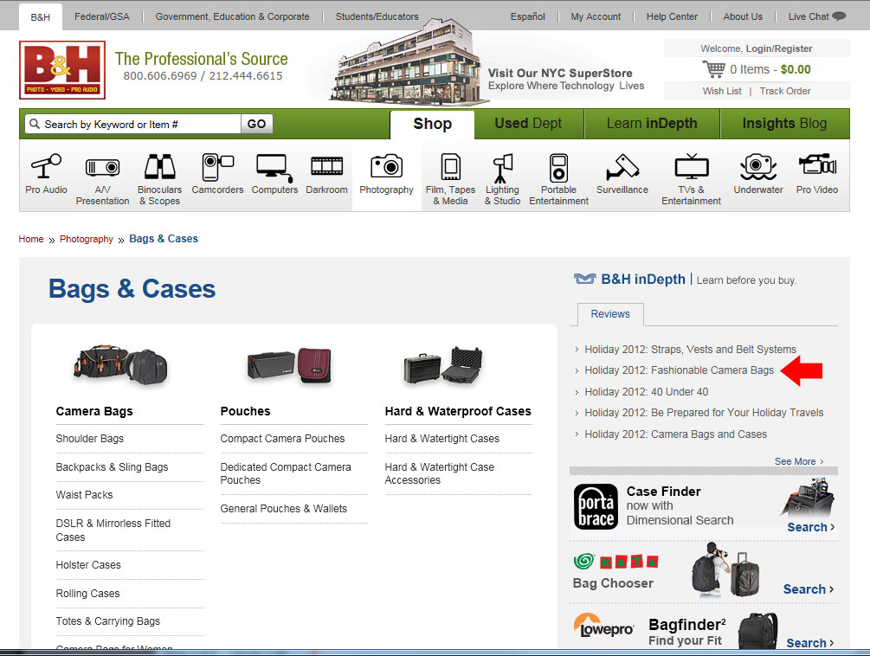

**Issue:** The link seemed a little dated. Holiday 2012. I am sure there have been a lot of bags released since. Actually all the articles say Holiday 2012. It makes it look like the site has not been updated very often.

**Principle:** Aesthetic and minimalist design

**Severity:** Low

**Solution:** Updated the post to include new bags or remove the Holiday 2012 from the title.

## [Product Listing Page](http://www.bhphotovideo.com/c/buy/ONA/Ntt/ONA014*/N/0)

*Clicked on ONA bags because they looked like nice leather bags, but it was too small. Because I came from a link on the blog, there was no option to see other bags that may be larger on the page. I had to modify the search to see all their bags to see if they had a larger size.*

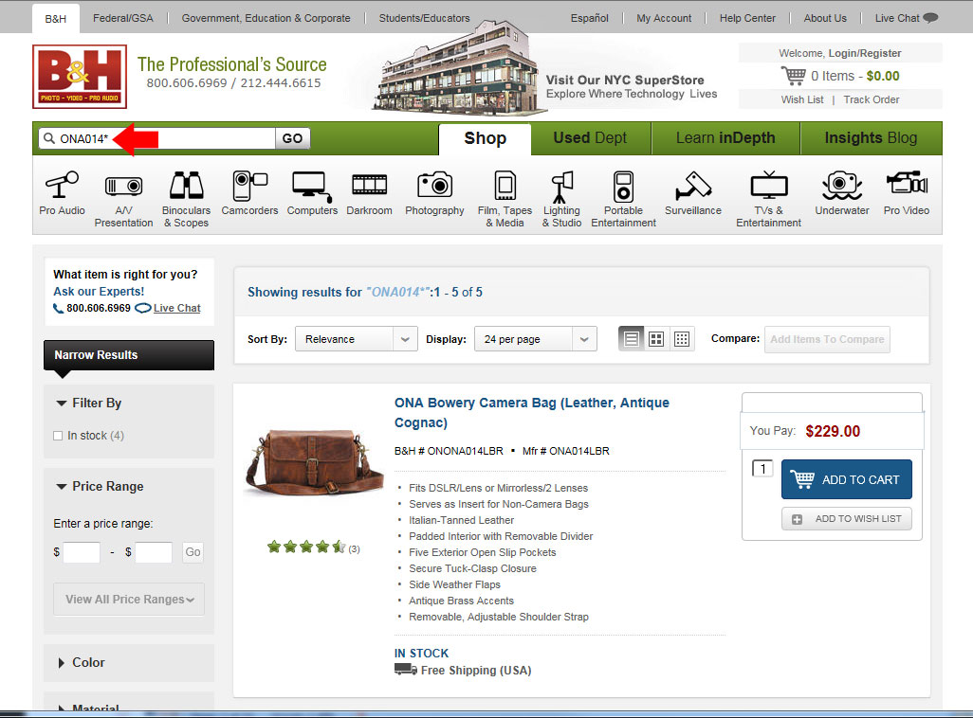

**Issue:** The filter is too limiting and should show more options. The search term in the top is ONA014. What does 014 signify. As a user I have no idea what that means or how to modify it other than deleting it all.

**Principle:** Flexibility and efficiency of use and Match between system and real world

**Severity:** Medium

**Solution:** Show all products from the manufacturer and give the options to filter. Don’t link out to such a specific search terms. It should me more general and something a user can easily recognize and modify. There should also be a X or clear type of button to clear the search results so I can search for something else without having to manually delete the last search result.

## [Detail Page](http://www.bhphotovideo.com/c/product/827144-REG/ONA_Designs_ONA007BR_The_Brooklyn_Shoulder_Bag.html)

*I look at the list for one that says it can fit an iPad. I find the Brooklyn bag. It only has two views and I cannot see the inside of the bag and how much it can hold. I go to the website of the manufacturer and they have more views including one inside view. I read the reviews and it seemed small and did not have enough pockets.*

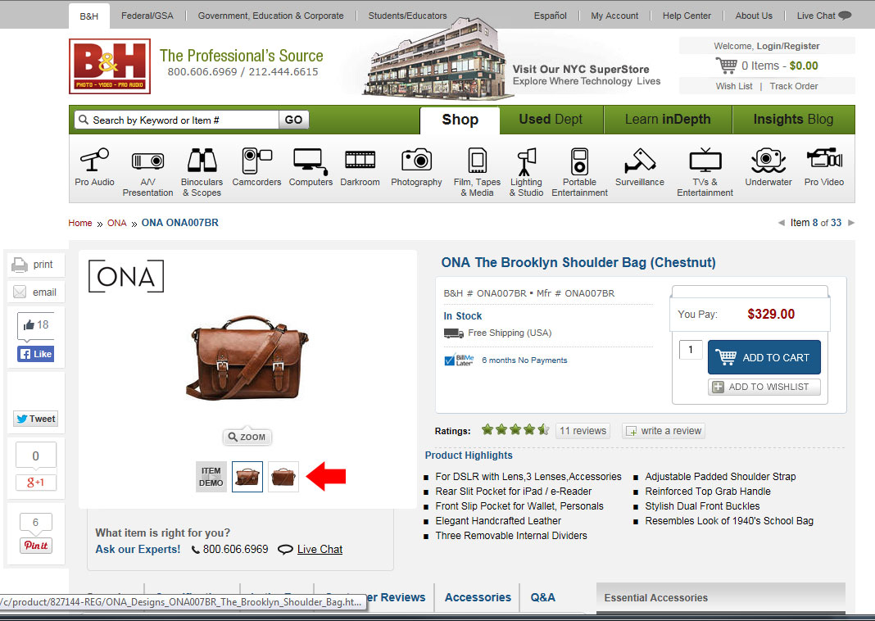

**Issue:** Not enough product shots. The most important photo for this type of product is the inside to get a sense of size.

**Principle:** Consistency and Standards

**Severity:** Medium

**Solution:** Show more product shots, especially if I can find it on the manufacturer’s site, otherwise people will leave and find it elsewhere.

*I went back to looking at the ONA bags. I looked at a leather messenger bag but a review said it was heavy. Next I started a new search by typing in the search field for camera bags. I got results with a small sort view by type across the top. It was helpful and I choose back backs and sling type. I then changed my mind, hit back and the sort view was gone. It would be nice if it was still there.*

*Scrolled through but there were too many options so I clicked on shoulder bags to narrow it down. I scrolled through and found that I liked the style of the Billingham bags so I checked the name on the left to give me a more specific list.*

*I clicked on the Billingham Hadley Pro. I noticed in the description the bullet points were off.  
  
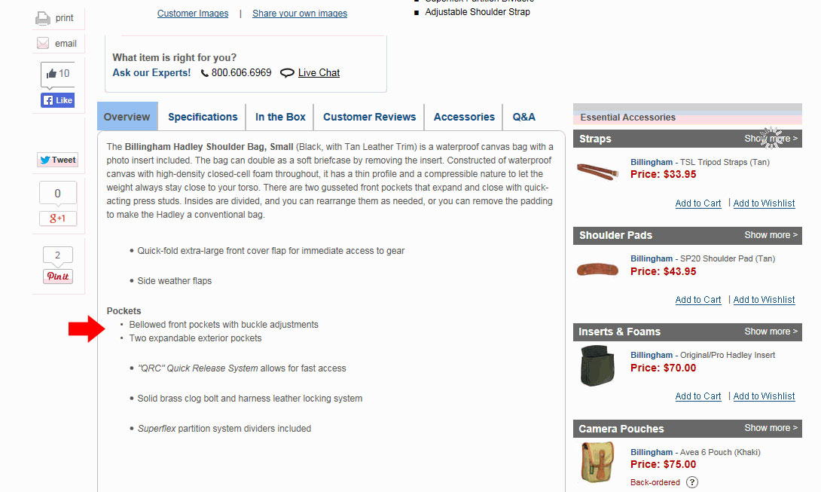*

**Issue:** The bullet points were not properly aligned.

**Principle:** Aesthetic and minimalist design

**Severity:** Low

**Solution:** Should be a simple fix in CSS to align them properly.

## [Customer Reviews](http://www.bhphotovideo.com/c/product/179303-REG/Billingham_503301_Hadley_Shoulder_Bag_Small.html)

*I went to read the reviews on the bag and I noticed some spelling errors by the people who wrote reviews.*

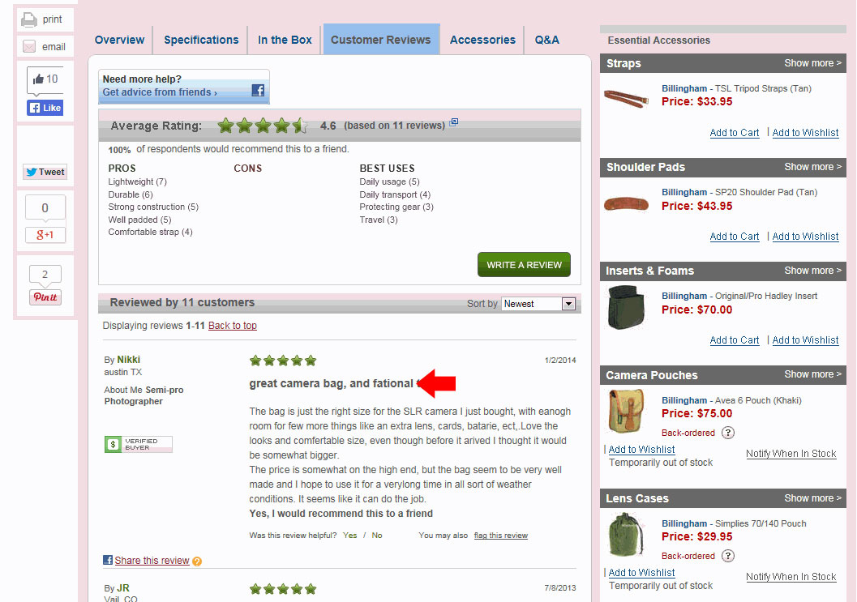

**Issue:**  Spelling errors

**Principle:** Error Prevention

**Severity:** Medium

**Solution:** Provide spelling correction in our form fields.

*While reading the reviews I noticed a photo uploaded by a customer who bought the same bag.*

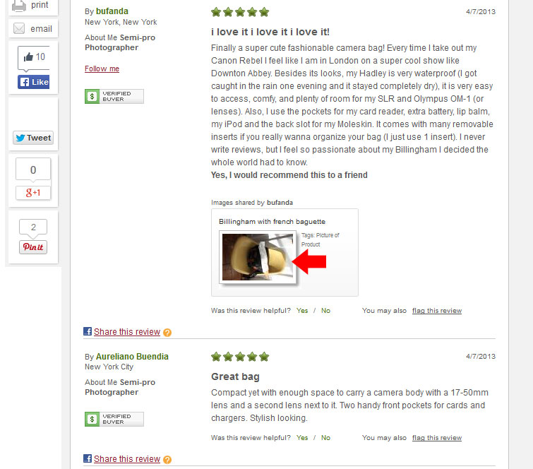

**Issue:**  The image they uploaded was horizontal when it should be vertical.

**Principle:** Error Prevention

**Severity:** Medium

**Solution:** I went to the area to add a review to see if I could change the orientation of a photo and I could not. Maybe we can provide a way for the user to see a preview before they post and give them the option to make basic changes to the images like rotation or flipping an image.

*I am not sure about whether I want this bag but I wanted more information so I clicked on “Follow this Product” I got a pop up where the submit button was overlapping the email address text input field.*

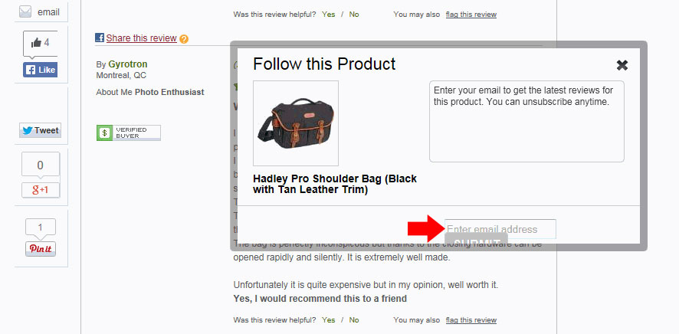

**Issue:**  The Window is too small for the contents of the page and things are misaligned.

**Principle:** Error Prevention

**Severity:** High

**Solution:** Should be a simpleHTML/CSS fix

*Curious about the “Need more help? Get advice from friends” Facebook button, I clicked it and got a pop up window thatwas very blank except for a link to “Log into Facebook”*

**Issue:**  The page could use a redesign to make it easier and more compelling to connect to Facebook. It does not entice me to click on it or give me any real information.

**Principle:** Aesthetic and minimalist design

**Severity:** High

**Solution:** A redesign to integrate better with Facebook and explain why.

## [Show More Accessories](http://www.bhphotovideo.com/c/product/179303-REG/Billingham_503301_Hadley_Shoulder_Bag_Small.html)

*I was interested in what accessories might be available for the bag. I clicked on the “Show More” strap button. I expected it to open below the button with more options. Instead it opened in the product information area. I still had to click on “Show more options” again to show the other straps.*

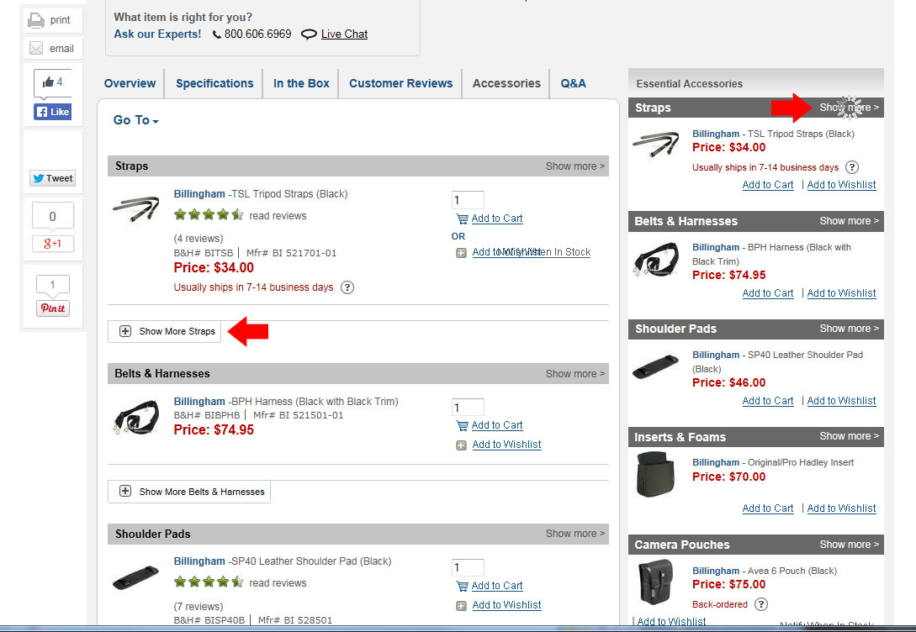

**Issue:**  having to click multiple times to see more options

**Principle:** Flexibility and efficiency of use

**Severity:** Medium

**Solution:** After clicking on “Show More” if it has to go in the product information area, then have the straps there already expanded so I don’t have to click twice. Other options might be to have the Accessories box drop down to show more accessories or to have a slider type view that the user can click to show the next accessories in that area.

*After looking at the accessories, I noticed the progress wheel is still there and spinning even after the action was already performed.*

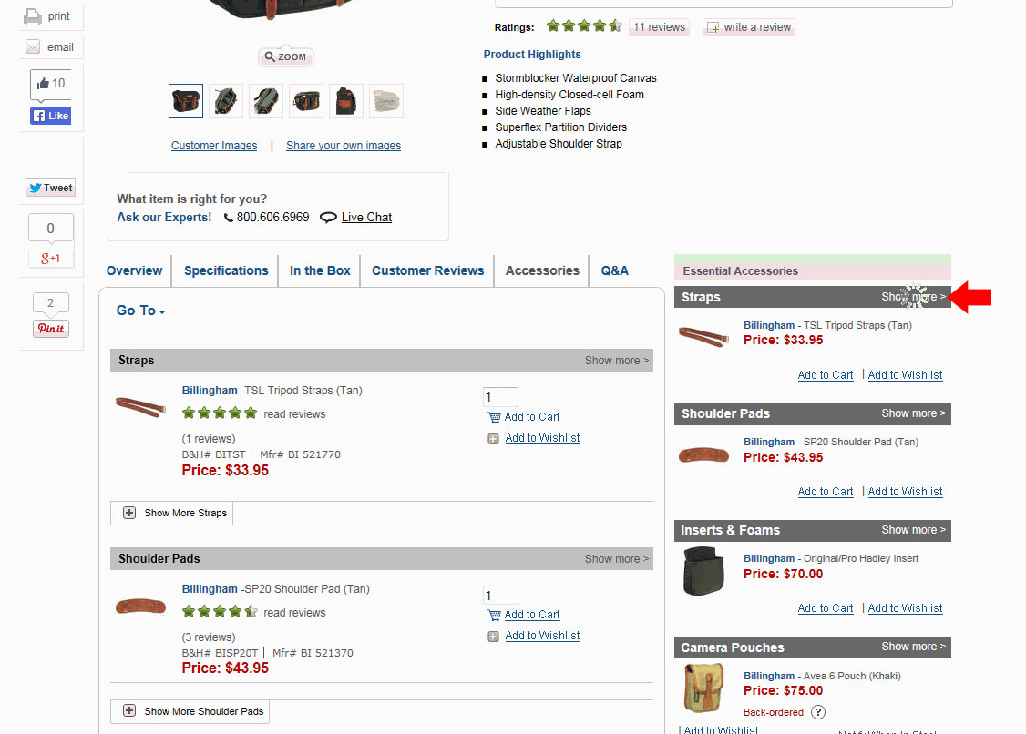

**Issue:**  Progress wheel not disappearing after accessories are loaded.

**Principle:** Error Prevention

**Severity:** Medium

**Solution:** Coding fix

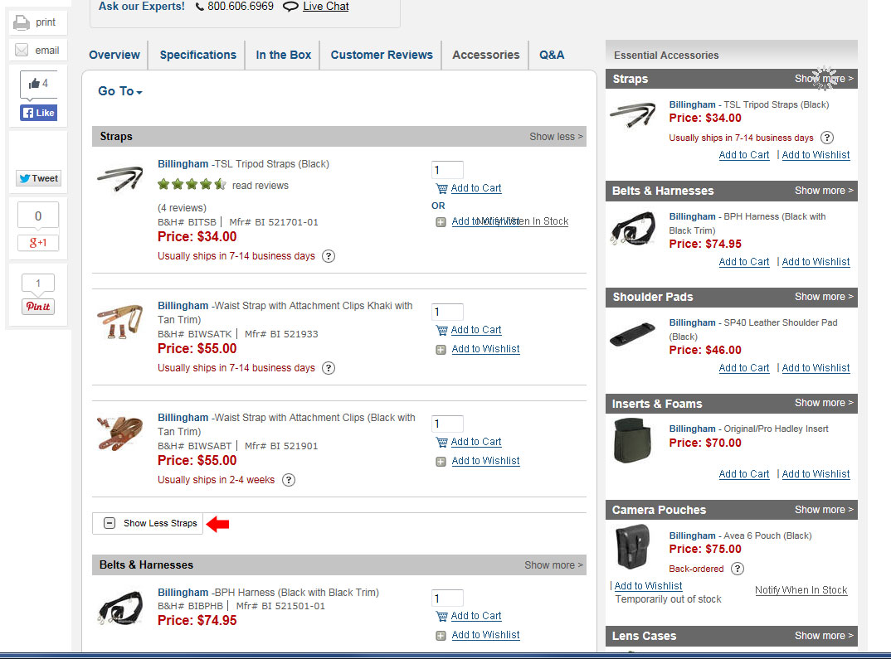

**Issue:**  Clicking Show Less Straps does not work

**Principle:** Consistency and standards

**Severity:** Low

**Solution:** Coding fix

## Checkout

*I go back to the listing page and decide to look at another. I like the brand and style but need something larger. I choose the Billingham Packington Shoulder Bag. I click on add to cart and then a screen pops up informing me of what I added to my cart. At the bottom I am asked about accessories. There are only two visible so I click on the “View All Accessories” button. It opens a new page with a nicely organized collection of accessories. I go through them all and get to the last one, “Care & Cleaning”. I am interested in that because I want a bag that is easy to clean and am curious to see what kind of products might be available to clean my bag. When I click on it, the view only contains a clip on cap holder.*

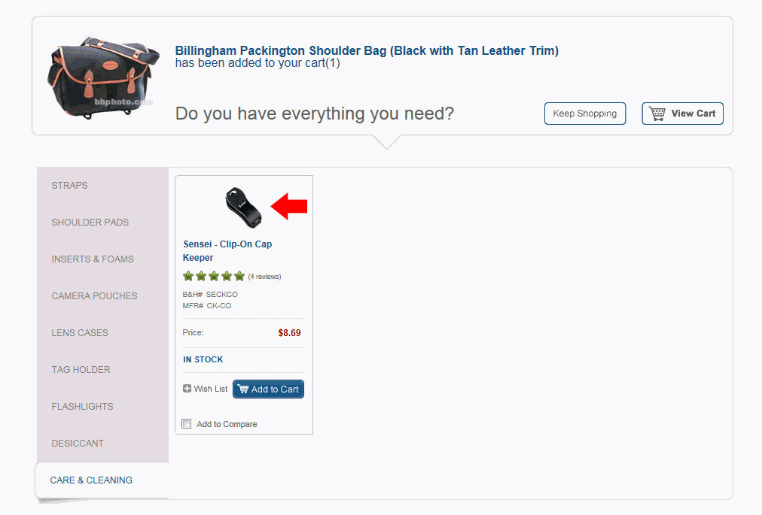

**Issue:**  Product is not relevant to the category it is in.

**Principle:** Consistency and standards

**Severity:** Low

**Solution:** Better off leaving it blank then offer something that is not relevant.

#### Various Issues

## Detail Page

**Issue:** When clicking on the product photos, I wanted to see the second image out of the four presented. When the pop up appeared, the default image is the first one. I would then have to click again to see the photo I wanted originally. When I click an image thumbnail, I expect the image I clicked on to show up, not another.

**Principle:** Consistency and standards

**Severity:** Low

**Solution:** Coding fix.

## Reviews

**Issue:** When I read reviews, I am not too sure who the reviewer is. They could be someone who hates Nikon cameras and all their reviews are negative so I may not give a lot of weight to that particular reviewer.

**Principle:** Help and Documentation

**Severity:** Low

**Solution:** Creating some sort of reviewer profile that shows other reviews they have made and the product they commented on. Something done by Amazon.

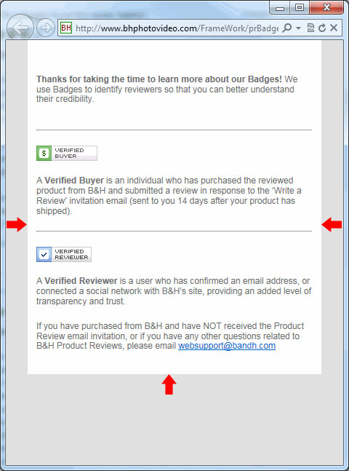

**Issue:** I clicked on the verified buyer badge and the pop up screen was too large.

**Principle:** Consistency and standards

**Severity:** Low

**Solution:** A simple CSS fix