16569 – B&H Hands-on Learning Videos

(Phase 2)

Contents

Purpose 1

1. Detail Page 2

Detail Page Indicator 2

Detail Page Content Panel 3

Designers Actions 4

# Purpose

The purpose of this document is to describe the requirements for the implementation of **Phase 2** of B&H Hands-on Learning Video series.

This document does not describe all the technical details of “how to implement”, but rather leaves this up to Dev/Designer to bridge the gap, if any.

Please refer to the full-sized **JPG Mockups** and **PDF Design Specs** for design requirements.

Feel free to contact me with any questions.   
Daniel Allegrucci x2089

# 1. Detail Page Player Enhancements

## Detail Page Indicator

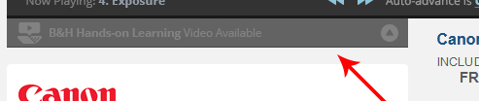

Figure

1. Hover and active state of button updated as above.

## Detail Page Content Panel

## G:\UXTeam\Projects\16569 - Hands On Learning Videos\FINAL\PHASE 2\Screens\specs-save-in-detail.jpgG:\UXTeam\Projects\16569 - Hands On Learning Videos\FINAL\PHASE 2\Screens\spec-saved-state.jpg

1. Clicking the heart saves the video for that model to Customer's My Videos list
2. If they are logged in when they click, change icon to "Added" state and the video is saved to their list.
3. If they are not logged in, the login layer appears with an brief explanation of the feature.
4. Sharing options will refer to "B&H Hands-on LEarning Video for the [Product Name]"
5. Shared links to will link to the detail page with the video player open and ready to play the video.
6. Beneath the video we display controls to load the next and previous chapters. These will be disabled as needed - if no next or previous chapter to view.
7. We'll also offer the ability to toggle Auto-advance. If auto-advance is on (default) then the next chapter loads and begins playing automatically when the current chapter is completed. This will be disabled if the video has only one chapter.
8. Chapters are displayed as pictured - in columns if more than 6. If more than 12, scroll chapter area.
9. There is a separate visual style for chapter buttons (rectangles with text beneath video player):
   1. default
   2. currently playing
   3. completed but not currently playing
   4. hover

# 2. My Videos in My Account

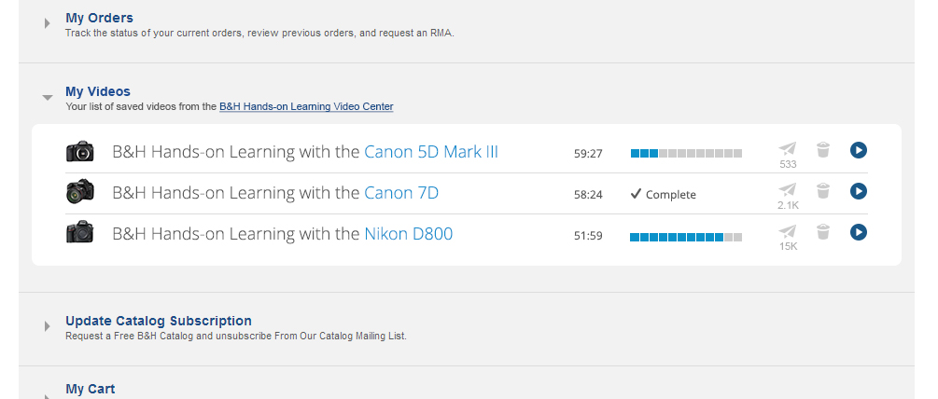

Figure 3

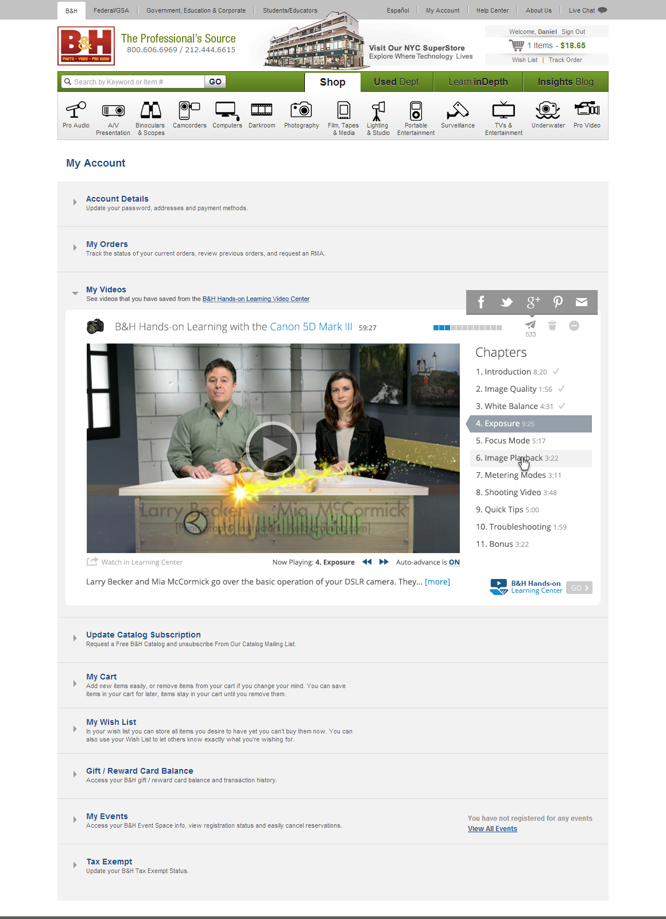

Figure 4

1. Videos that the user saves to My Videos will appear in a My Videos section under My Account.
2. If a user purchases a product that has a Hands-on Video available, the video will be automatically saved to My Videos (if he is logged in during checkout). We will send him an email that will link to the My Accounts page with the My Videos section open and video open and ready to play.
3. Normally, videos in My Account appear in their collapse state.
4. Users can remove videos from My Videos using the trash can icon
5. Share (paper airplane) icon will display the total number of shares beneath it. Users will be able to share a link to the video (in its location in the video center) to Facebook, Twitter, Pinterest, G+ as well as email the link to a friend.
6. Play icon expands the listing to full video player. The icon toggles into a close/collapse icon (- inside circle).
7. Clicking video title or thumbnail also expands video in place and toggles play/close icon.
8. Under video player there is a link to watch that video in the Hands-on Video Center.
9. Below that a there is summery of the video. One line shows, is truncated and ends with "..." and a "more" link that reveals the entire summary. The bottom of the white container is pushed down as needed to accommodate the additional text.

# 3. B&H Hands-on Learning Video Center

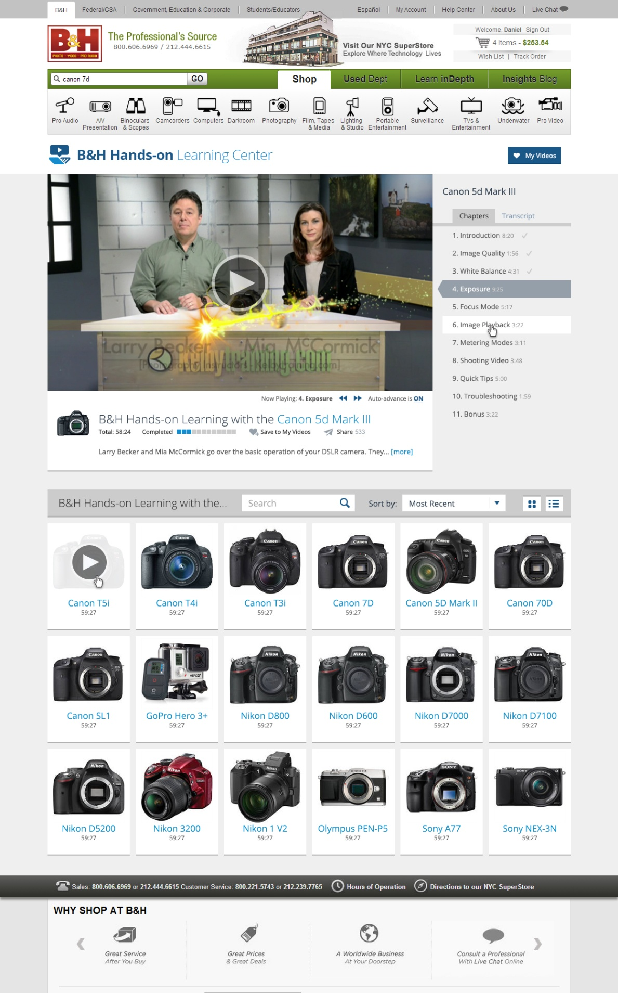

Figure 5

1. The B&H Hands-on Learning Center will be a publically accessible location where users can access all Hands-on videos.
2. We will offer search, sort and viewing format (grid/list) options for finding available videos.
3. Public links to Hands-on videos should point here with the respective video loaded into the player.
4. If a user comes here without following a link to a specific video, a featured video will be initially loaded into the player.

## My Videos Quick View

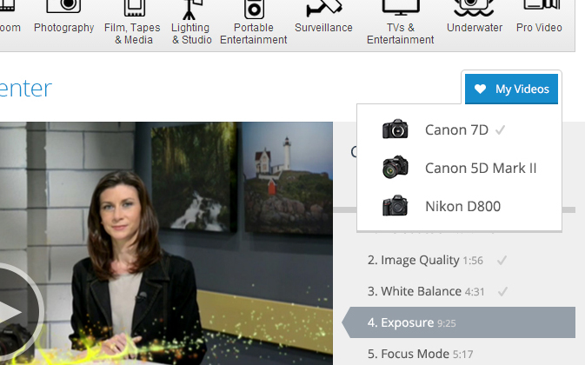

Figure 6

If they are not logged in, they'll see a message advising them to log in and explaining the feature.

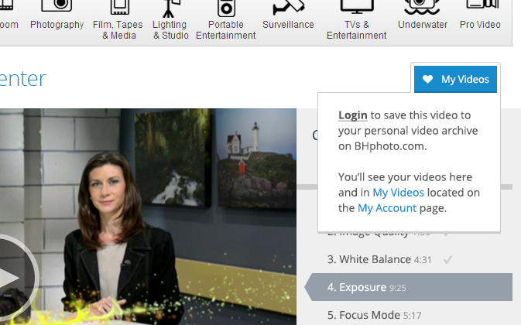

Figure 7

1. If a user hovers over My Videos button and they are logged in, they will see a thumbnail and title for their saved videos.
2. They will see a check mark if the video has been completed.
3. If they are not logged in, they will see message briefly explaining the feature and prompting them to login/create account.
4. If they choose to login/create account, show standard login dialog in center of screen (or panel in the case of the detail panel)

____________________________________________________________________________________________

# Designers Actions

Please see the Design Spec PDF Documents and Full-sized JPG Mockups for detailed design specifications.