Heuristic Review

Contents

Introduction 2

Use Case 1: Buy a Home Entertainment System 2

Landing Page 2

Product Listing Page 3

Detail Page 4

Use Case 2: Buy a wide angle lens 9

Detail Page 9

Order History with Store Orders 12

Use Case 3: Holiday Shopping (Wish List) 16

Use Case 4: Selling My Camera 18

Quote page 18

Use Case 5: Purchasing a Home Music Production Studio 19

Use Case 6: Purchasing a High End Camera 21

Acessory Intermediate Page 21

Use Case 7: Looking Up an Old Order 22

Product Detail Page 22

Order History 23

Conclusion 23

# Introduction

The following is a heuristic review of the B&H site conducted with the aim of identifying specific issues to address. I will set up a variety of user stories to work my through realistic flows. I'll document my reaction in a "think out loud" format (in *italics*) and, then when finished, format the problems and recommendations in condensed document.

# Use Case 1: Buy a Home Entertainment System

I am a customer ready to buy a home theatre system. I want to listen to music primarily, then I'm interested in movies and maybe gaming. I'm hoping to keep it under $1000 for a complete package, but could be persuaded to spend a little more if it seems worth it.

## [Landing Page](http://www.bhphotovideo.com/c/browse/Home-Entertainment/ci/4600/N/4294544179)

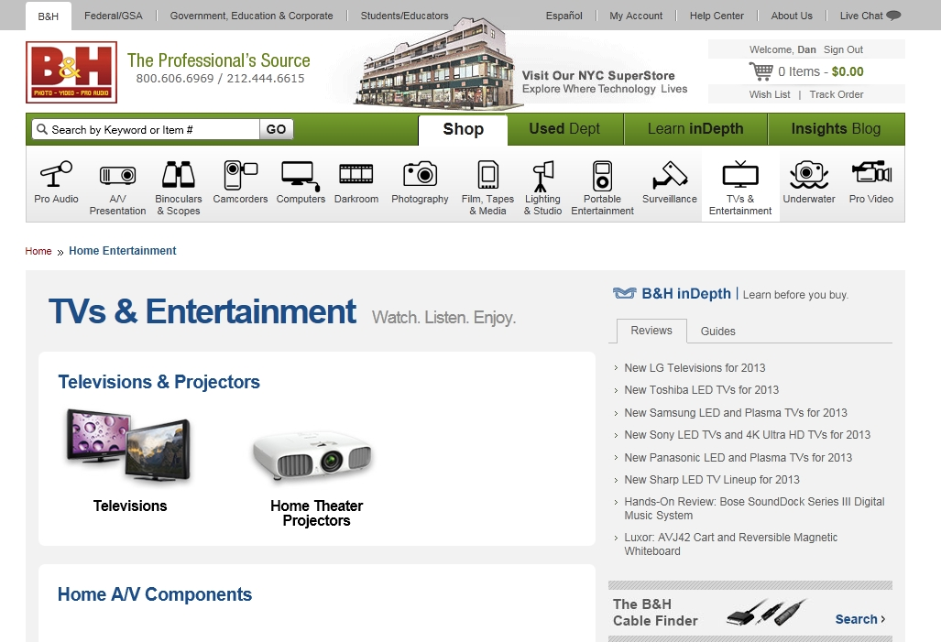

**Issue:** It can be hard to tell that there are additional product categories below the fold.

**Principle:** Recognition rather than recall

**Severity:** Medium

**Solution:** Show the user more clearly that there is a reason to scroll. The white containers on gray background are low contrast. Possibly darken the gray background or use other visual device to reinforce grouping even if the fold occurs immediately after 1st row. Or use a device other than separate white containers (rule?) to separate categories of product.

**Issue:** The B&H inDepth panel appears to contain only reviews at first glance.

**Principle:** Recognition rather than recall

**Severity:** Medium

**Solution:** Make tab navigation more prominent

*I scanned the guide to Home Theatre Receivers. I'll choose one of those first. I click Home Theatre Systems and Receiver. The first product I see is a $79.99 Receiver that doesn't seem to be geared toward home theatre. The next one is $448 and lists home theatre-related specs.*

## [Product Listing Page](http://www.bhphotovideo.com/c/buy/Home-Theater-in-a-Box/ci/2520/N/4041617487)

*I decide I want a package. Starting with just a receiver seems like a lot of work... I find the "Home Theatre in a Box" link on the left.*

*This is what I'm looking for. I'm happy to see terms listed in details that I just learned in the guide (ARC, etc.). I'm seeing 2 Yamaha systems that are comparably priced and may even share the same product image... wait there is a third. I'm not sure what the differences are between these 3 systems. I'm afraid I might spend too much for features I don't need or opt out of something I don't yet know I need. One has many more reviews than the others and is highly rated. This makes me think it may be a safer bet.*

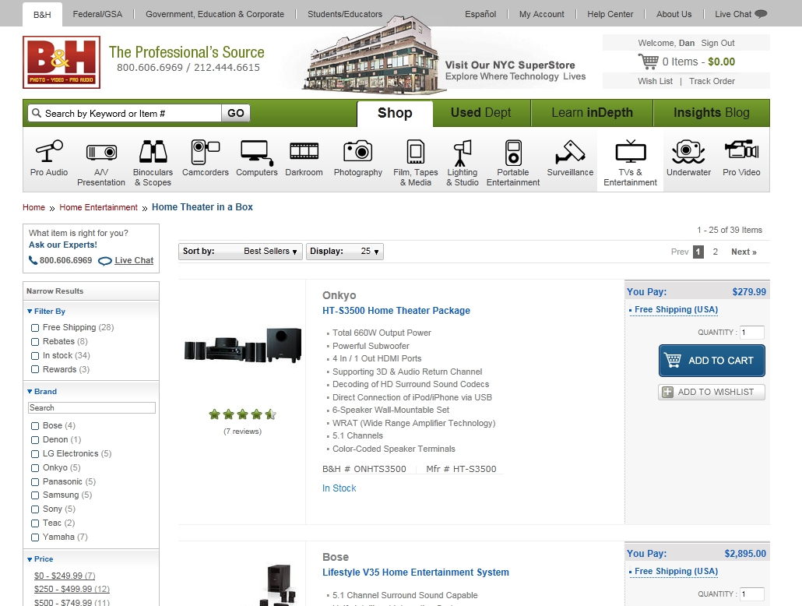

**Issue:** Difficult to compare features of similar products.

**Principle:** Consistency and standards

**Severity:** Low

**Solution:** Create "compare" functionality to allow user to see selected product specs in a table or other legible form. (I later discovered this functionality for TVs. I then assumed I had just overlooked it here, but confirmed that it is not available. Why can I compare TVs but not stereos?)

## [Detail Page](http://www.bhphotovideo.com/bnh/controller/home?O=NavBar&A=getItemDetail&Q=&sku=850160&is=REG&si=rev#costumerReview)

*I'll check out the one with all the reviews. I glance at the picture, highlights, then click on the Reviews button. The page automatically scrolls down then selects the reviews tab and displays that content. This is a little confusing for a moment. "Whoa, what's happening to my page? I'm not driving any more."*

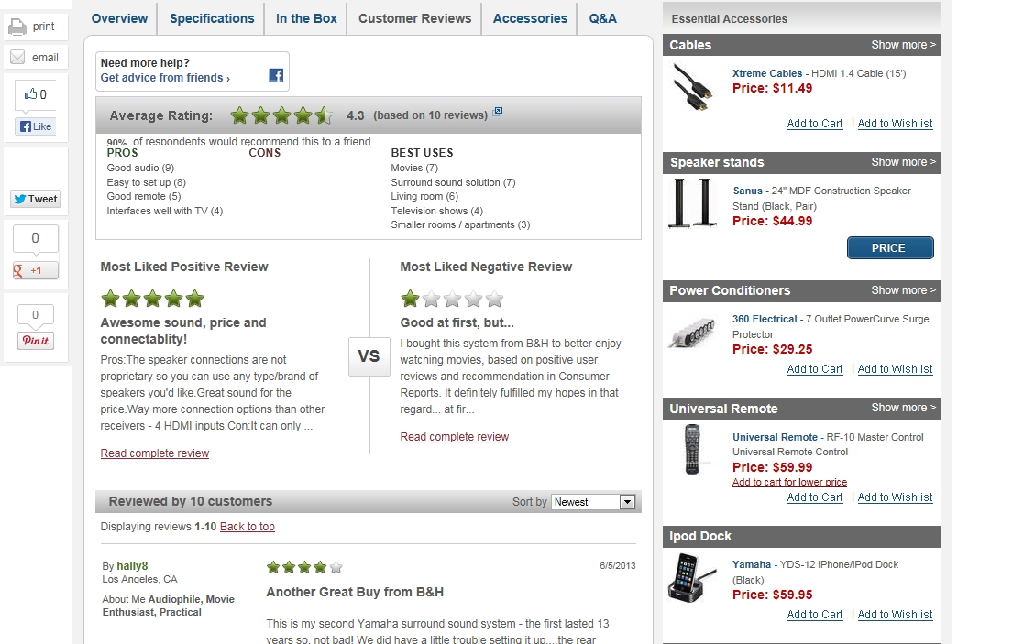

**Problem:** Automatic page scrolling and tab selection is a bit disorienting.

**Principle:** User freedom and control

**Severity:** Medium

**Solution:** Change to review tab before automatically scrolling page to reduce number of activities that seem to be outside the user's control.

*I click "Read Complete Review" for the featured negative review. The complete review comes up in a modal window. I start to scroll but the page scrolls. Then I'm scrolling in the modal box. Then I get to the end of the content and pages starts scrolling again. I getting a little confused and frustrated. I tried the featured positive review and it scrolls, too*.

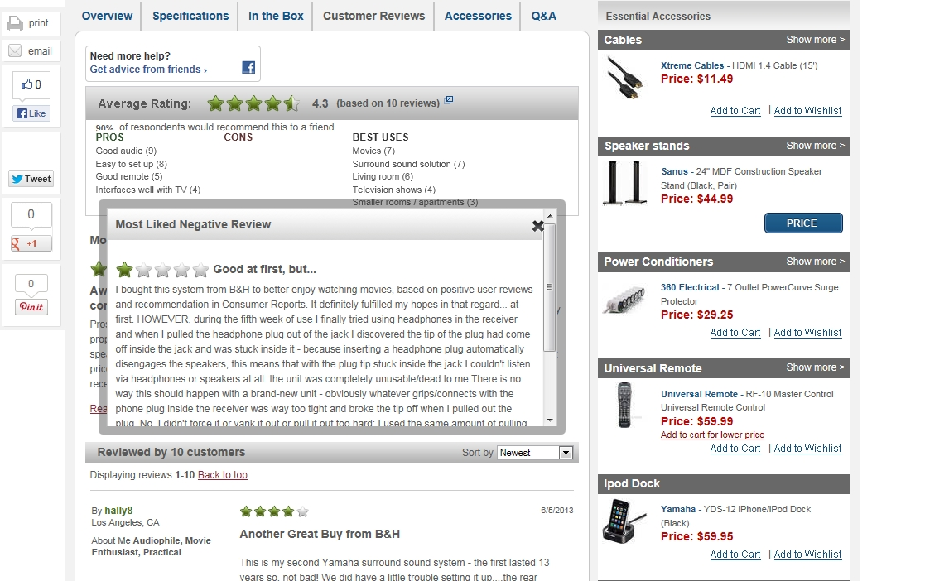

**Problem:** Transparent border of modal window and narrow padding allow underlying content to crowd modal content. Scrollbar crowds "X" when present.

**Principle:** Aesthetic and minimal design

**Severity:** High

**Solution:** Adjust position of "X" if scrollbar is present. Make borders of modal opaque and/or increase padding of content area in modal.

**Problem:** Long reviews in modal window create confusing scrolling situation.

**Principle:** User control and freedom

**Severity:** Medium

**Solution:** Make modal large enough to show content without scrolling the modal. Or discontinue use of the modal and auto scroll page to the review as it appears below. User will already be familiar with auto scrolling behavior.

*OK, I added it to my wish list. Now I will select a TV... I've got about $570 left to spend and recently saw a friend's 55" TV. That seemed like a good size. We'll see if I can afford one. I click the TVs& Entertainment icon in the main navigation, then Televisions. I immediately go to the left sorting menu and decide I'll select everything from 55" down to 46". I can see those 2 are common sizes along with 50" by the quantity in parentheses. I click 55" and before I can click anything else, the page reloads and I'm no longer looking at the part of the menu I'm concerned with. I'd like to click all 5 boxes, but I really don't feel like waiting for 5 page loads. So I will focus on the 3 common sizes in my range 46, 50 and 55". Having to scroll back to that part of the menu each time seems like a lot of work... I'm eager to shift my attention to the filtered results - that's fun, not work.*

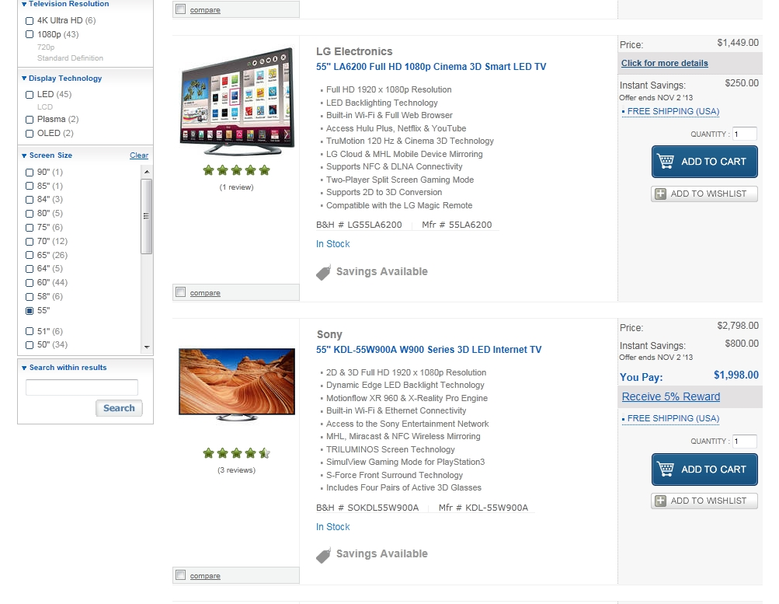

**Problem:** Multiple selection in sorting bar causes multiple page loads, forces viewer to scroll down and reorient each time.

**Principle:** User control and freedom

**Severity:** High

**Solution:** Reload products asynchronously (like Zappos). Or offer sliders for numeric parameters that might be searched by range.

*Then I selected the price range ($500-$749.99). Again, I wish I could narrow it down to a few products and compare the main features. Wait... I can! I didn't see it. This helped me see that the largest one I selected is the cheapest, though it has no reviews. I now have a curated set of information on which to base my decision.*

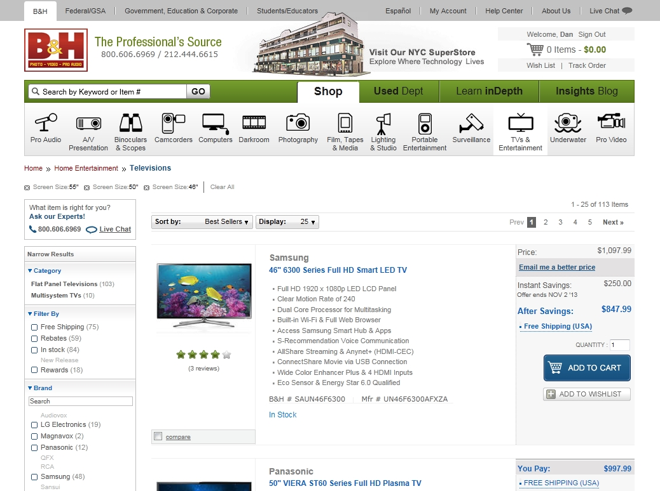

**Problem:** Compare feature is easily overlooked. (Or I had already looked for that feature in Home Theatre Packages and did not find it)

**Principle:** Consistency and standards

**Severity:** Low

**Solution:** Make checkbox and text more prominent in color, size or positioning.

*I wish there was a TV buying guide. I'm unsure about the differences between and plasma and LED and imagine there are a lot of features that have recently been introduced that I'm not aware of.*

*Regardless, I'm ready to buy these things. What accessories do I need to avoid the disappointment of having my new system that I can't use until I get some cable, mount or, accessory? I go back to the TV detail page from my wish list. I check the" In the Box" tab to see if it includes anything I might otherwise buy. Then I try the Accessories tab. I like being able to see product details for suggested accessories without navigating away (the convenience outweighs the scrolling issues). I love being able to "Show More Cables." I added cables and speaker stands to my cart. Can I assume all these accessories will work with this receiver? I'm not sure.*

# Use Case 2: Buy a wide angle lens

I am novice photographer trying to buy a wide angle lens.

*On the home page, I select lenses from links under Photography. I click on SLR Lenses in the left sorting menu. I click Nikon under Lens Mount in left sorting menu. Then I click Wide in the same menu. Then I click $250 - $499.99. I find a lens to take a closer look at...*

## [Detail Page](http://www.bhphotovideo.com/c/product/66980-USA/Nikon_1919_Wide_Angle_AF_Nikkor.html)

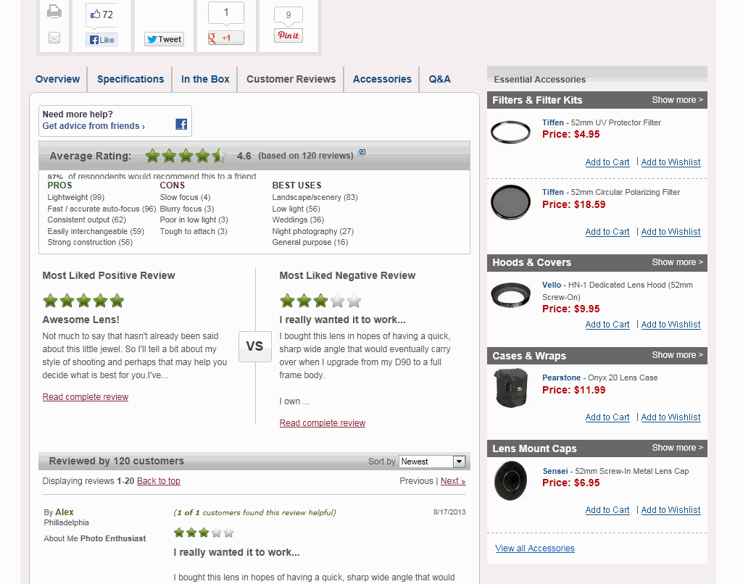

**Problem**: Text under gray "Average Rating" bar is cut off on the bottom.

**Principle**: Aesthetic and minimalist design

**Severity**: High

**Solution**: Should be a simple CSS fix

*I'm disappointed to see a note that my camera model does not support AF. I try* [*another product*](http://www.bhphotovideo.com/c/product/822797-REG/Rokinon_FE8MAFN_8mm_Ultra_Wide_Angle.html)*. The product image options, including customer provided photos are fantastic. I notice the link "Receive a 4% Reward" and click it. A modal comes up.*

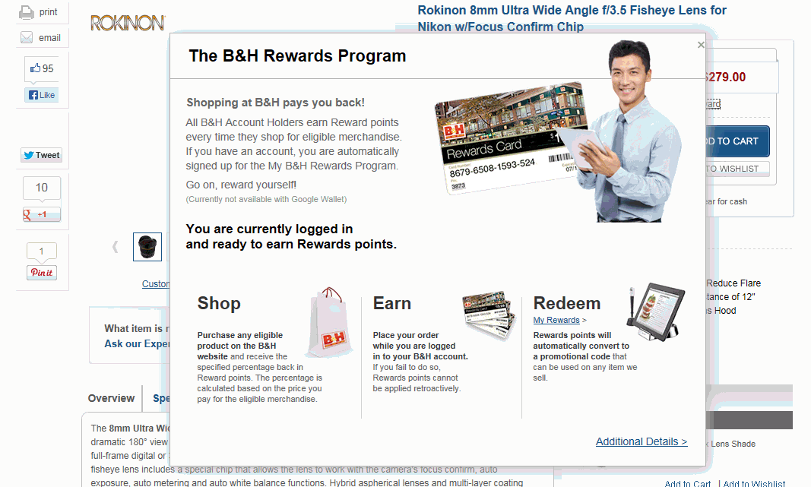

**Problem:** "X" is flush with right edge of modal.

**Principle:** Aesthetic and minimalist design

**Severity:** Medium

**Solution:** Should be simple CSS fix

*I scan the content in the modal and click "Additional Details." It takes me away from the product detail page to the rewards page. The rewards page doesn't have a lot of additional content, now I'm starting to forget about the lens I was interested in.*

**Problem:** "Additional details" takes me away from my primary task without offering much to justify it.

**Principle:** User control and freedom

**Severity:** Medium

**Solution:** Load additional content into modal, remain in product detail page.

*Now I'm curious to see if I have any rewards credit waiting to be used since it says I'm automatically enrolled. I click the "My Rewards" link under redeem. It takes me to the middle of a page and prompts me to enter a card number and pin. I'm confused. I thought I was automatically signed up, but now I wonder if I need to get a card somehow. I'm not sure what to do.*

**Problem:** "My Rewards" link takes user to a place where next steps are not apparent

**Principle:** User control and freedom.

**Severity:** High

**Solution:** Provide instructions or explanation . Possibly set expectation more clearly. Is this program primarily for camera equipment?

*Then I click "My Account" thinking I might be able to find the balance there. I am a little disoriented to find I'm already on that page, but have been automatically scrolled to a certain part of it. I click "Account Details" and am prompted to provide my password. I do so. I don't see anything about rewards here. I click "Order History." No orders show. Maybe I've only bought things from the super store... I expand the range to see if I have older orders on record.. I can't remember. I notice the "Add Phone & In-Store..." box. I enter my email and phone number.*

**Problem:** Left edge of submit button is lighter than rest of edges. Gray in corners of button does not match gray of background.

**Principle:** Aesthetic and minimalist design

**Severity:** High

**Solution:** Recreate button.

*I am prompted to check my email and confirm my address. The email has some formatting issues:*

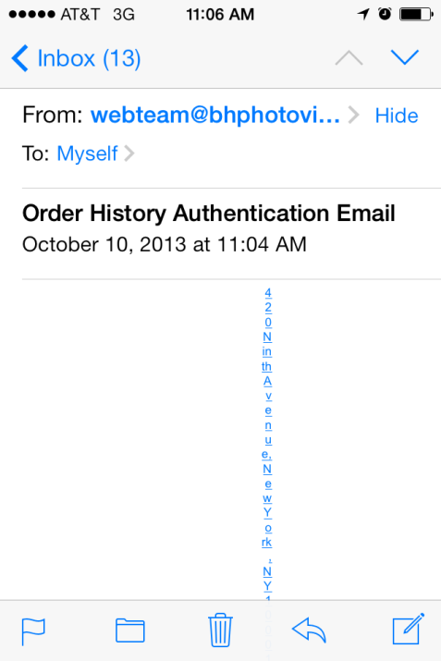 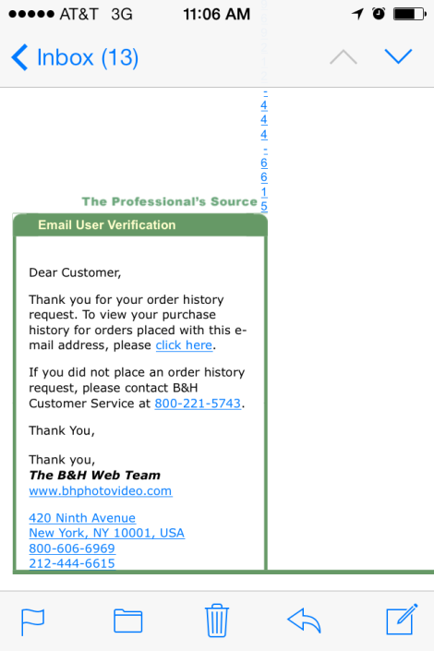

*Now I can see my STORE orders. Cool! In the "Order History" table the Tracking column for STORE purchases I see the value "Pending..." This is a little unsettling since these orders are closed and in the past, yet this status implies something is ongoing.*

## [Order History with Store Orders](http://www.bhphotovideo.com/bnh/controller/home?O=orderHistoryReturns.jsp&A=showOrderHistory&Q=)

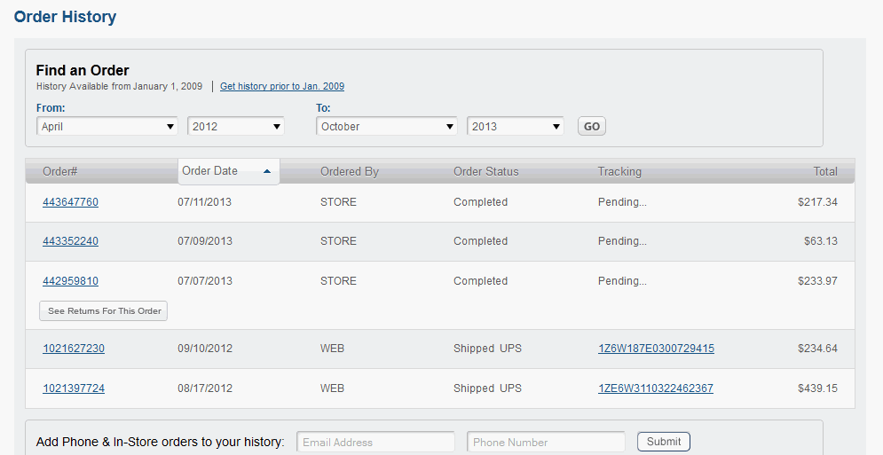

**Problem:** Tracking status for store orders ("Pending...") is potentially confusing.

**Principle:** Match between system and real world

**Severity:** High

**Solution:** Change status to" N/A", " - ", "None" or something else that does not imply further activity on the order.

*I still see the "Add Phone & In-Store" box. Will I need to supply this information again or have I permanently linked In Store purchases to my online account?*

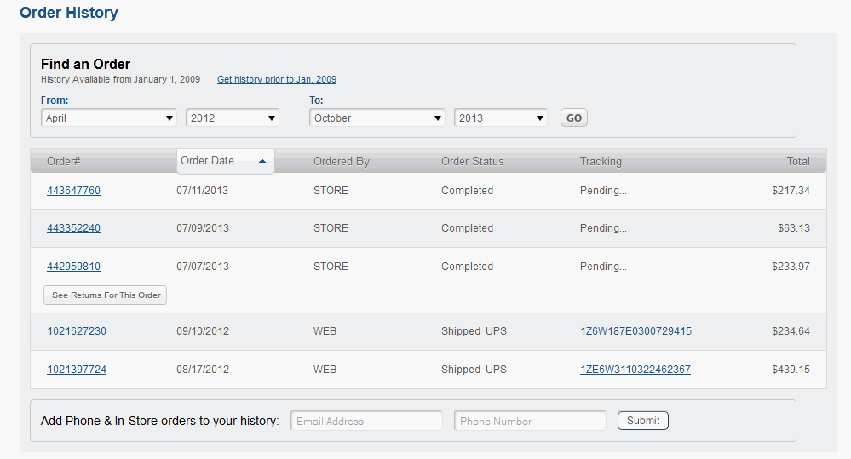

**Problem:** Prompt to add phone and email persists after user has added them.

**Principle:** Aesthetic and minimalist design

**Priority:** Low

**Solution:** Do not display this box after user has provided this information.

*I tried to modify the range of transactions after being idle for a while. I was prompted to enter my password. When I did, the action I initiated was ignored and I had to modify the range again. It would be nice if it would have displayed the new range after I submit the password rather than discarding my request.*

**Problem:** If user is idle for a while, his next request is met with a prompt to provide his password. He is then returned to the pre-request state.

**Principle:** User control and freedom

**Severity:** Medium

**Solution:** Save the request somehow and apply it after user provides password.

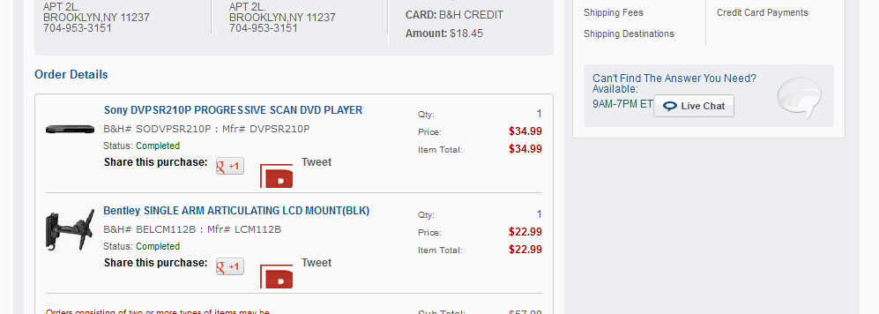

**Problem:** Twitter logo in "Share this purchase" feature is oddly sized/cropped.

**Principle:** Aesthetic and minimalist design.

**Priority:** High

**Solution:** Replace with a appropriately sized logo (note: I later realized that this is probably a result of B&H internally blocking whatever image is being called.)

**Problem:** No space between Live Chat button and preceding text

**Principle:** Aesthetic and minimalist design

**Priority:** High

**Solution:** Add space

*I still don't know if I have any rewards credits. I'll try the Help Center in the top nav. I see "Check Gift Card Balance" under "Customer Self Service." I click that and it takes me to a page that allows me to enter card numbers and pins. I'm wondering if I have a bunch of points I don't know about. I'm getting a little obsessed about it.*

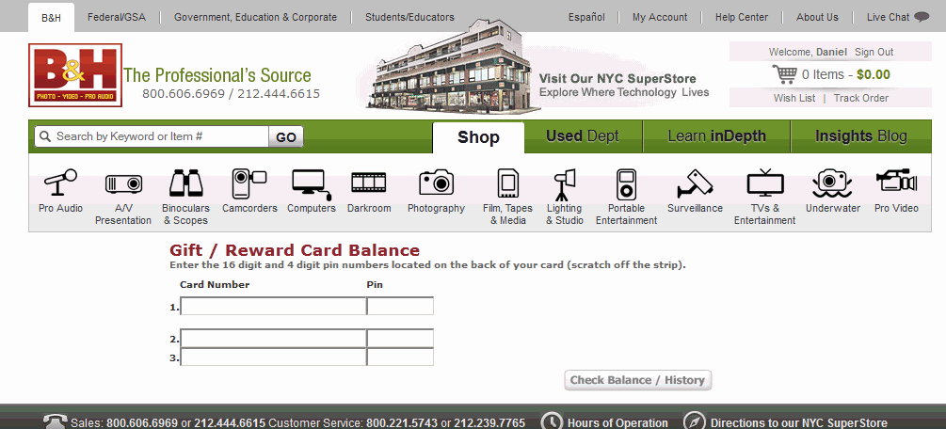

**Problem:** Form fields appear inconsistent with others on the site. This page looks old.

**Principle:** Consistency and standards

**Priority:** High

**Solution:** Update code for styling elements to bring in line with current standards

*I enter "rewards" into the search box. I'm unsure if this will search help content as I already associate it with product information. It takes me to a "Rewards Program" page. It might be helpful to explain that the products that show the "Receive 4% Reward" link are eligible.*

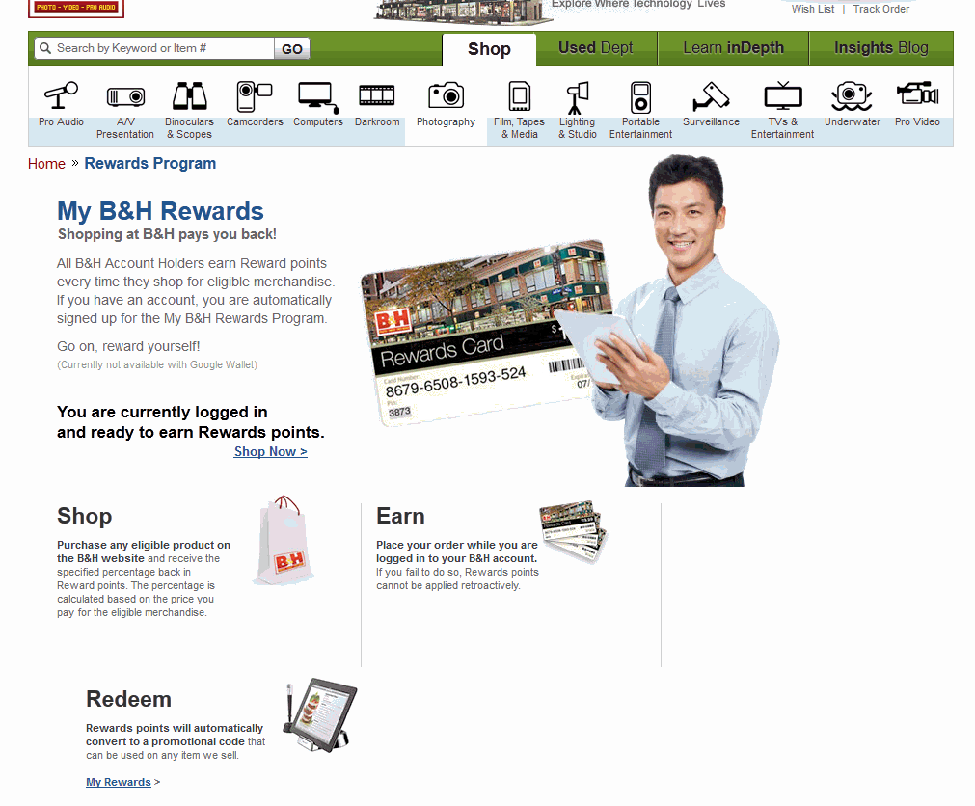

**Problem:** Three column row breaks into second row.

**Principle:** Aesthetic and minimal design

**Severity:** High

**Solution:** Troubleshoot CSS

*At this point I give up. It was an interesting proposition, but I can't figure out how to take advantage of it. I don't know if or how many points I have, if I need a card or not and what items are eligible. I wish there was a clearer explanation, I feel like I might be missing out on something.*

*I click Shop Now. It takes me to last item I was viewing. Does that mean it's eligible?*

**Problem:** Rewards program is hard to decipher.

**Principle:** Consistency and standards

**Severity:** Medium

**Solution:** Provide more detailed information about program somewhere.

# Use Case 3: Holiday Shopping (Wish List)

I'm about to start shopping for gifts for the holidays. I'm always looking for more efficient ways to do this and wonder if the wish list might be helpful for this in addition to storing items I want for myself.

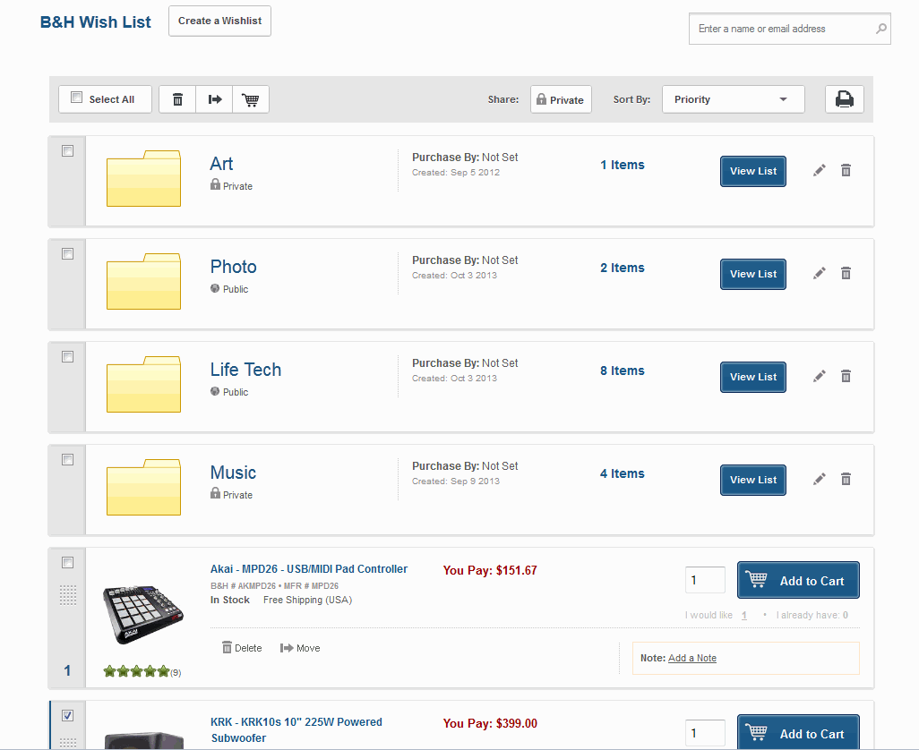

*I added a couple items for a particular family member. I like that the notification overlay appears, but the footer animates up and covers it partially before I can read it sometimes. Also there seems to be extra space beneath the text in the overlay.*

*The list customer created wish lists show a manila folder icon instead of a product picture. When I see the of the individual items I want, I get excited. When I see the folders, I associate them with business, taxes, MS Windows, etc. They sort of put a damper on the fun of wanting these products. Maybe the folders could be colored or maybe the image could be a box with products inside. Or maybe it could show a little folder in the corner and have another subtle cue to differentiate it from an individual product, but show image for the first or highest priority. Or maybe individual items should appear before lists. It seems there is no way to take an item out of custom lists and back into the master list.*

**Problem:** Process for priority on products in wish list is not clear. I'm not sure how the scale works - is it a ranking or is each priority level a class that can be applied to multiple objects? It took me a long time to discover the blue numbers as clickable and associate them with the idea of priority.

**Principle:** Recognition rather than recall

**Priority:** High

**Solution:** Move priority indicator and add label. A something to click on to get a quick explanation or create a visual cue that indicates the nature of the priority scale.

**Problem:** Manila folder image separates user from the emotional connection to the products he or she has selected.

**Principle:** Recognition rather than recall

**Priority:** High

**Solution:** Replace folder with image of first, highest priority or most expensive product in that list and add other device to indicate it's a list rather than a single product.

# Use Case 4: Selling My Camera

I'm considering selling my camera and will investigate the process.

## [Quote page](http://www.bhphotovideo.com/find/trade-in.jsp)

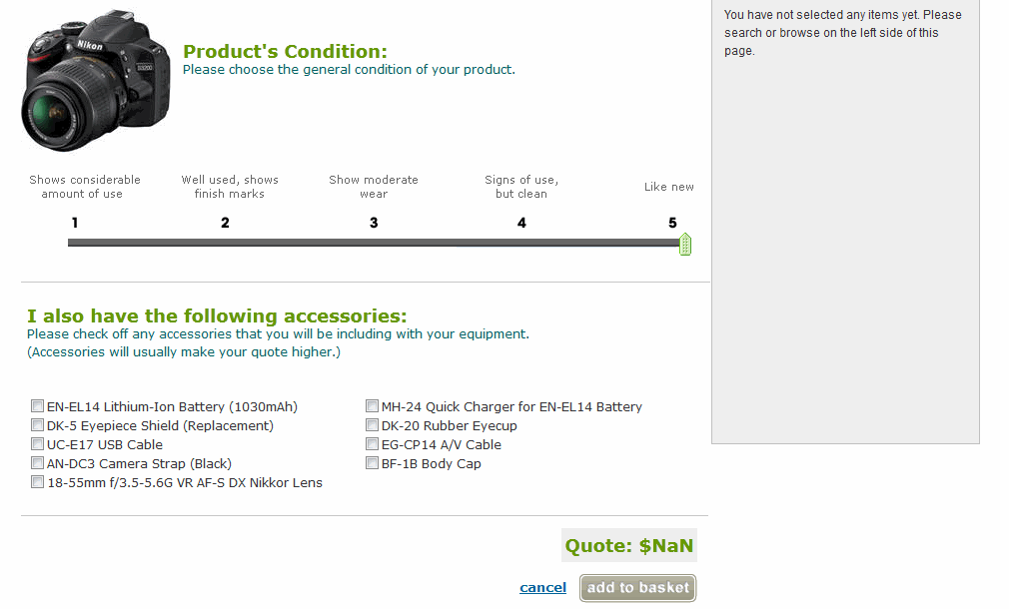

**Problem:** Product Condition slider can be moved beyond its maximum value, resulting in an invalid quote value.

**Principle:** User control and freedom

**Severity:** Critical

**Solution:** CSS/Javascript bug fix

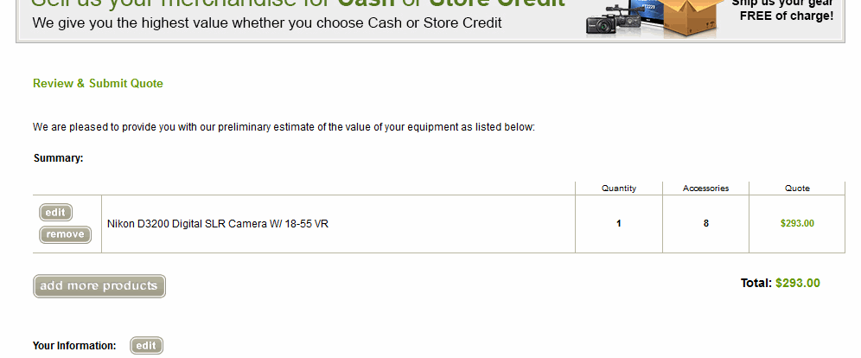

**Problem:** The buttons (as well as tables, headers, etc.) in this area have a distinctly different look than other parts of the site

**Principle:** Consistency and standards

**Severity:** Medium

**Solution:** Replace buttons to be consistent with site wide style

*I was shocked at how low the quote was until I began adding the accessories that came with the camera. It would be great to quickly give a sense of how much the whole package would be worth. I'm looking at the quote and comparing that number to what I paid for the package. By the time I added everything that was included, I was satisfied with the number. But I was tempted to abandon the process when I saw the initial low figure.*

# Use Case 5: Purchasing a Home Music Production Studio

I want to start a home digital music studio and purchase the equipment to get started. (On staging)

I put a bunch of items in my cart and will now check out.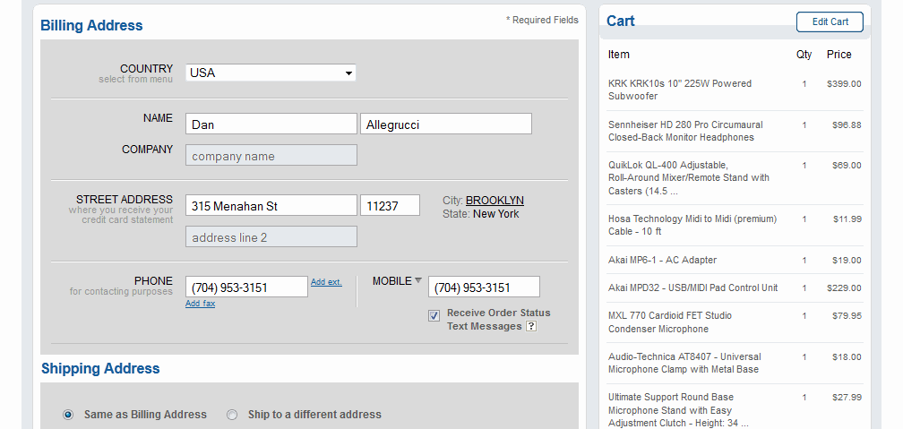

**Problem:** Phone is required but then there is a separate field for mobile with additional functionality offered for that number. My only phone is mobile. User may be confused - should they enter their number twice is they only have one number, it's mobile and they want to receive SMS updates?

**Principle:** User control and freedom

**Severity:** Medium

**Solution:** Allow users to select text messaging for primary phone number.

*I've placed my order, but just realized I don't need one of the items I've ordered. I hope I can modify my order or make a return easily.*

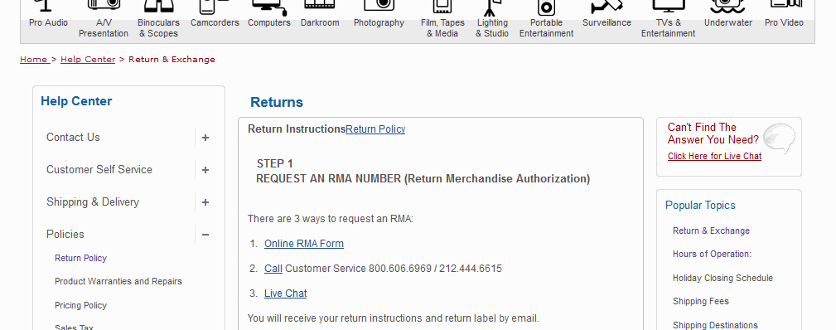

**Problem:** Typographical issues - headlines are indented. No space between "Return Instructions" and "Return Policy" once you click Return Policy.

**Principle:** Consistency and standards

**Severity:** Medium

**Solution:** Move rest of content to the right to line up with headlines. Add space and pipe to "Return Instructions" at top.

*That went pretty well. Now I realized I don't need the cable. I can't request a return authorization. I see I can modify or cancel the order. I make a request to modify the order. I have to refer the product by typing out the whole name and I have nothing to refer to on this screen. It would be nice if I could see the details of the order for reference when I'm typing my request.*

# Use Case 6: Purchasing a High End Camera

I've decided to buy a Canon 5D Mark III and lens.

## [Acessory Intermediate Page](http://webstage.bhphotovideo.com/bnh/controller/home?O=productDetail&A=accessoryIntermediate&Q=&sku=847546&is=REG)

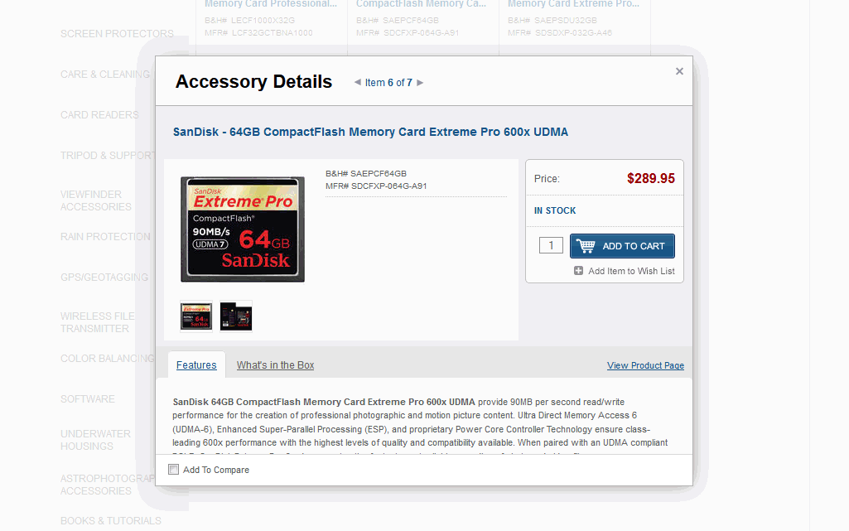

**Problem:** Easing on animation for text area seem exaggerated. It continues to move as I'm trying to click the "What's in the Box" tab.

**Principle:** User control and freedom

**Severity:** Medium

**Solution:** Modify easing of animation

**Problem:** Left transparent background border image on modal is the wrong size

**Principle:** Consistency and standards

**Severity:** Medium

**Solution:** Troubleshoot CSS/JavaScript/image

# Use Case 7: Looking Up an Old Order

I was talking to a friend who is in the market for a projector. I told him about one I bought from B&H and he asked me how much it cost. I can't remember so I'll look it up.

*I look around for a bit -I want to click "Welcome Daniel" to get to my account details. I have to hover over things to figure out if they are links or not. I eventually find "My Account" in the top bar. I expand the date range since I know it was a while ago. I click "My Orders" and enter my password. I'm not sure which order to click on... I look at the total amounts to narrow it down. I found it - I paid $424.95. I'm curious to see how much it sells for now so I click the product link.*

## [Product Detail Page](http://www.bhphotovideo.com/c/product/827038-REG/POWERLITE_X12_MULTIMEDIA_PROJECTOR)

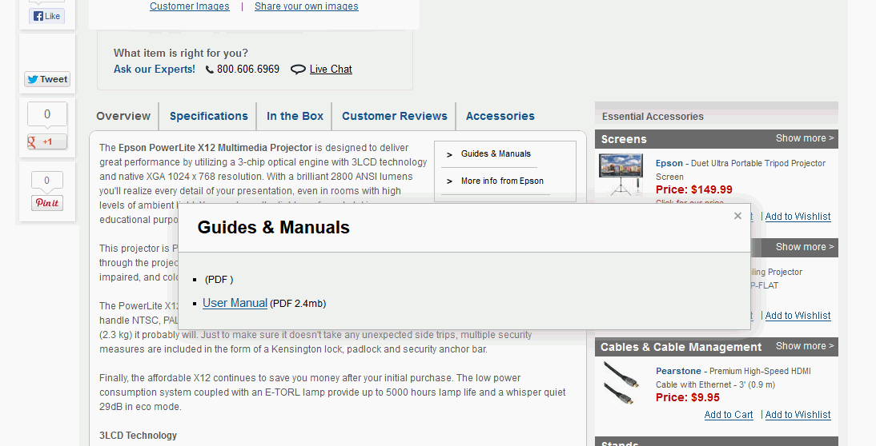

**Problem:** 2 item unordered list seems to have only one valid item.

**Principle:** Consistency and standards

**Severity:** High

**Solution:** Remove the first item.

## [Order History](https://secure.bhphotovideo.com/bnh/controller/home?O=myAccount&A=orderHistory&Q=orderHistory)

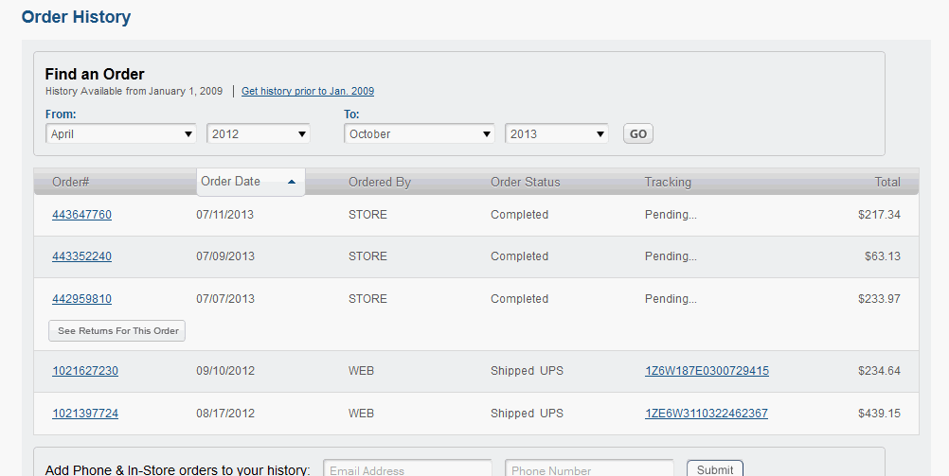

**Problem:** Users may think of orders in terms of what they bought rather than the date or amount. The order history does not offer any direct correlation between orders and the merchandise purchased.

**Principle:** Recognition rather than recall

**Severity:** Medium

**Solution:** Add an image of the most expensive product in the order to each listing in the order history. Maybe this is activated on hover or is always present. Possibly offer the option to turn images off as some high volume customers may prefer a simpler and more compact layout for this table.

# Conclusion

Overall, the site provides an excellent experience to the customer. Some of the user stories I attempted resulted in 0 issues to report. Continued review, voice of customer and voice of associate as well as ongoing analysis of competing sites will surely reveal additional opportunities for improvement.