Ecosytem – ie nike “plus” products work together to create something greater than the sum of their parts.

The word **ecosystem** comes from biology wherein it describes a network of interacting organisms and their physical environment. From a technological standpoint, though, an ecosystem is better described as a network of people interacting with products or services. As [Dave Jones defines them](http://uxmag.com/articles/design-for-a-thriving-ux-ecosystem), ecosystems include:

* **users,**
* the **practices** they perform,
* the **information** they use and share,
* the **people** with whom they interact,
* the **services** available to them,
* the **devices** they use, and
* the **channels** through which they communicate.

**Ecosystem thinking,** likewise, is the *inquiry* method used to analyze and understand ecosystems, both the problems they pose as well as the business opportunities they might present. Instead of focusing on a single product or service, however, designers who practice ecosystem thinking evaluate user behavior at the intersection of various inflection points. They ask:

* Who are our users?
* What practices do they perform?
* What information do they need? (and where do they seek it?)
* With whom do they interact?
* What services are available to them?
* What devices do they use?
* Through what channels do they communicate?

Answers to these questions provide designers with all of the raw data they need in order to better understand the ecosystem in which they’re working. Turning that data into actionable information is the job of ecosystem maps.

An **ecosystem map** is simply a graphical representation of the relationships examined via ecosystem thinking. Ecosystem maps are closely related to other diagrams with which designers are likely familiar, including [service blueprints](http://www.servicedesigntools.org/tools/35), [experience maps](http://www.adaptivepath.com/ideas/the-anatomy-of-an-experience-map/), and [concept maps](http://www.uie.com/articles/concept_models/). They differ from these diagrams, however, in that ecosystem maps are optimized to aid in the creation of digital strategies.

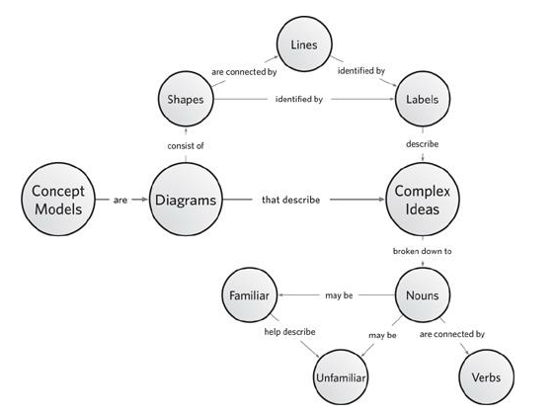

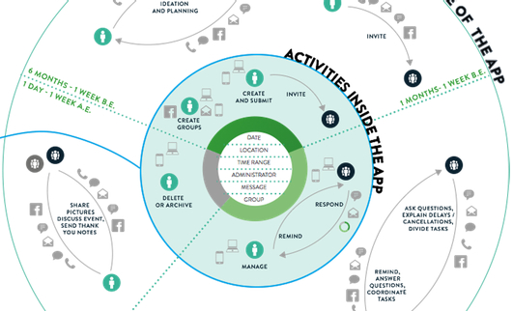

The map also shows how activities are performed through the use of icons: invitations, questions and responses can be submitted through regular mail, e-mail, text message, in person, over the phone, or through Facebook. Timeframes for the various activities appear as green, dotted lines. In this case, I chose to use large timeframes as the timing varies a great deal across different types of events (planning a wedding might take six months, whereas planning a night out at the movies might take hours).

The inner circle of the map shows the activities that the app currently supports; the other circle shows what’s on our minds. Deciding what to do during an event and sharing photos are but two examples of countless activities that users might perform during the course of organizing an event. This division—what users do vs. what we support—is an excellent jumping off point as we formulate our digital strategy.