Wish List Desktop

1. Wish List Main Page Behaviors
2. Default Wish List is always at the top
3. If the customer has no items in their wish list then we put suggestions to view the most popular cameras or other categories.   
     
   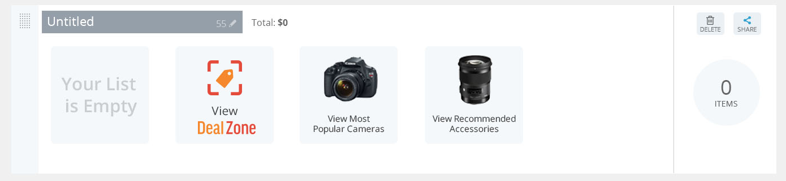
4. When the user creates a new wish, it will be below default and above all the other wish lists they may have.
5. Rolling over an item will bring up the detailed view allowing the user to add to cart or and two small bars on each side will let the user know they can move it to another wish list. Clicking on the item will bring the user to the detail page of that item.  
     
   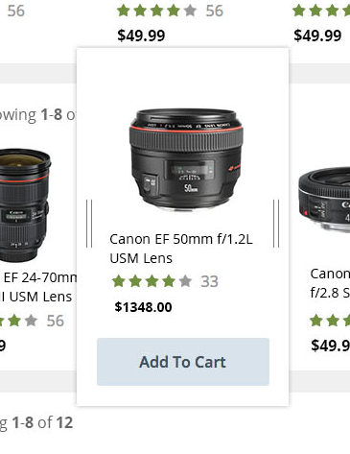
6. If the list has more items then what can fit, the Showing 1 – however much is in their cart will show up. They will also be able to arrow through the wish list by clicking on the arrows.
7. At the end of each wish list will be a total of the items in the wish list, a delete button (except for the Default which cannot be deleted) a share button and a total of the cost of the items in the list  
     
   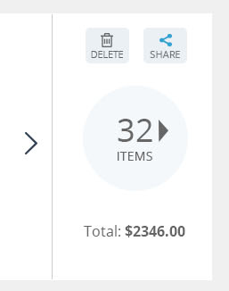
8. On the right of all the wish lists (except for Default) there is an icon allowing the user to reoder the list by grabbing it and moving it.
9. Clicking delete will bring up a notification telling them it has been deleted and will disappear in 3 seconds.
10. Share and Setting
11. Wish Lists are Private by default
12. By default in the share dialog, email will be selected. This will have the URL that the user can copy and paste manually or if they click on the email button it will bring p their default email client.or limited.
13. Clicking on URL will bring up a field that has the URL with a copy button allowing the user to copy and share. Clicking on any of the social media icons will make the list automatically public in the setting section.
14. In Settings they will have two choices, Private or Public. If they click on Private after sharing the link and a person tries the link after it has been made private, they will get an error message letting them know that the user made it private.

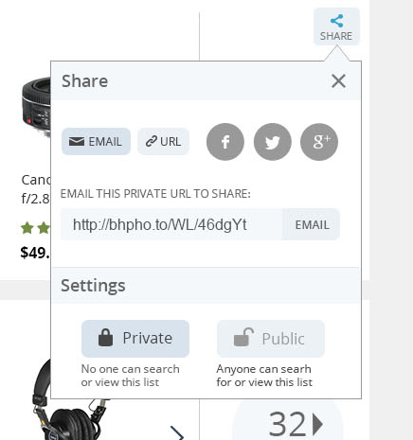

1. List View
2. The title for each wish list is editable by clicking on it. Hitting enter or clicking elsewhere on the page will confirm the change.
3. Clicking on sort by will give the user the ability to switch between the priority set by the user (date added if they have not changed anything) Price, Date Added, Purchased, Product Name.
4. Clicking on the move button will give the user a drop down list with all their wish lists.
5. Default ship to works the same way it does in checkout.