Hi Sam,

Here are some Value Propositions for the page. How many do we want and which ones do you want to feature before I go off and design them?

1. Fast and Free Standard Shipping
2. Award winning customer service/Expert Help
3. Huge selection/ Tech Wonderland
4. Same Day pick up
5. Superior Value

“When I saw the first page, you have a lot of electronics there. I did not equate that or make the connection with creativity. When I come to this page, it speaks to it. It’s the feel and the theme here. When you come here, it feels like it talks about photography and music and art, but that’s not what I got from that first page. I was not expecting this.”

Based solely on their impressions of the homepage, participants were asked to characterize the brand in 3 words.  
  
Communication  
Creative  
Customer-focused  
Engaging  
Equipment  
Exciting  
Focused  
Fun  
Innovative  
Inviting  
Modern (x2)  
Motivating  
Technology  
Wow  
Accessible   
Creative  
Familiar  
Friendly  
High-tech  
Professional (x2)  
Quality  
Reliable (x2)  
Specialized  
Technology  
Trustworthy  
Unknown  
Value

It’s focusing on products that are geared towards people who want to create something. Not just people who want to consume media or just watch things, but people who want to actually do something, create something, make something to share.”

**What exactly is a Value Proposition?**

A truly great value proposition introduces you to prospective buyers and helps you make a strong first impression. Your value proposition should describe; how your product or service solves/improves problems, what benefits customers can expect, and why customers should buy from you over your competitors.

**What is a Value Proposition?**

A truly great value proposition is a statement that paints a clear picture of what your brand has to offer for prospects. According to an infographic from [QuickSprout](http://www.quicksprout.com/2014/12/03/how-to-write-a-great-value-proposition/), it tells your audience:

* How your product or service solves/improves problems
* What benefits customers can expect
* Why customers should buy from you over your competitors

A value proposition is a statement that answers the ‘why’ someone should do business with you. It should convince a potential customer why your service or product will be of more value to them than similar offerings from your competition. You know why your company is great, but do your potential customers know what sets your brand apart?

**Top Characteristics of a Great Value Proposition**

* Be concise and easy to understand
* Define what you do
* Make it easy for someone to find you in an online search
* Explain how your product resolves a pain point for your potential customer
* Be displayed prominently on your website and/or your consumer touch points
* [Answer the question](https://marketingexperiments.com/value-proposition/6-good-2-bad-b2b-b2c-value-proposition-examples): “If I am your ideal customer, why should I buy from you instead of any of your competitors?

## ****Most Common Value Proposition Mistakes****

Good value propositions can be as elusive as a unicorn, but that doesn’t mean they can’t be found (or in this case, created.) But as you read earlier, most marketers struggle with putting a good value proposition together. Here are a few common mistakes that can get in the way of creating good value propositions.

### **Not Having Proof**

Of course you love your product, of course you think what you’ve got is the best ever, but should you say that? No. If your value proposition declares that you have “the most easy-to-use marketing automation platform” on the market, you’ve got to back that up.

Take Zoom video conferencing, for example. Its claim that it is the “#1 video conferencing and web conferencing service” is backed up by a Gartner analysis. But you don’t have to have a study by a leading IT research and advisory firm to back up your claims. Case studies and customer testimonials can also give you the proof you need.

These customer testimonials from [Basecamp](https://basecamp.com/) help drive home its selling point that it makes businesses more efficient.

### **Not Being Clear**

We’ve all been there. Having visited a site or read about a product and being left with the question: “But why should I *care*?” It’s easy to see why people should buy your product or services when they’re *your* product or services, but for everyone else, you need to clearly communicate exactly what sets you apart.

If your site or value proposition doesn’t clearly and quickly communicate your selling points and why someone should should become a customer, your potential customers are going to find a company that does, and you’ll see that in your site’s bounce rates.

### **Not Testing**

Believe it or not, A/B testing can also be helpful when crafting a compelling value proposition. See what kinds of terms perform best by A/B testing conversions on your site. You can also find which language resonates with your potential customers by using PPC ads, according to Marketingexperiments.com.

In [its example](https://marketingexperiments.com/value-proposition), the company uses PPC ads for an ISO test company. Each ad contains a different set of keywords. Then, based on the clickthrough rates of each ad, you can determine which value proposition resonates best with your potential customers.

A good value proposition can be the difference between your next customer or another bounce statistic. Creating a compelling value proposition doesn’t have to be overwhelming. Clearly communicating what makes you unique (without being too clever) with proof and testing can help you stand apart from your competition.

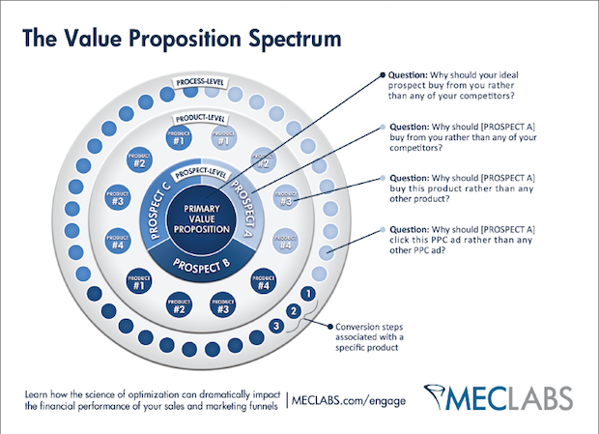



**For [target customer] who [statement of the need or opportunity], our [product/service name] is [product category] that [statement of benefit].**

Example: “For non-technical marketers who struggle to find return on investment in social media, our product is a web-based analytics software that translates engagement metrics into actionable revenue metrics.”

**We help [X] to [Y] by [Z].**

Example: “We help parents spend more quality time with their kids by providing parent-friendly play areas.”

[**Peter Sandeen**](https://blog.kissmetrics.com/dominate-your-market/) says the idea is to “hit people over the head with what makes you different.”

**What makes you valuable?** (Collect all of the most persuasive reasons people should notice you and take the action you’re asking for.)  
**Can you prove that?** (Use studies, testimonials, social proof, etc. to prove your claim.)

