**B&H Current Values**

**Edu**

Get Great gear at great prices

450K items

Free Shipping

Expert Help

Plus exclusive discounts

Now in stock

**B2B**

Reps you can rely on

Competitve Pricing

Tax Exempt Status

Instant Quotes

Net Payment Terms

Pay with Purchase Orders

**Main site**

People not algorithms

Whatever you need, We’ve got it

Principles over profits

Superior Value

Family Affair

Tech Wonderland

Tech corner

**What our customers say**

Communication

Creative

Customer-focused

Engaging

Equipment

Exciting

Focused

Fun  
Innovative

Inviting

Modern

Motivating

Technology

Wow

Accessible   
Creative

Familiar

Friendly

High-tech

Professional

Quality

Reliable

Specialized

Technology

Trustworthy

Unknown

Value

**Competitors**

Adorama

Buy online, pick up in store  
Avoid the lines with fast and free store pick up!  
  
Photography Equipment, Video Gear, and Electronics  
We are the world’s only full-service destination for photo, video and electronics. We’re more than a camera store—we offer the best selection and prices on professional photography and video gear, pro-audio, and consumer electronics such as home theaters, mobile computing, home office equipment and more.

Equip Your Creativity  
Our Mission  
We believe everyone is a creator. Our mission is to inspire, educate and equip to make dreams a reality.  
  
Our Vision  
Be an integral part of every creator’s success story.  
  
Our Pledge  
Keep you inspired and connected to our pros and your peers.

We See It Your Way

If you’re going to manifest your creative vision, you need the right equipment. At Adorama, our store has been an icon for New York City’s creatives since 1974. Read more about our history.

Shop Adorama for a powerhouse lineup of cameras, lenses, cinematography gear, studio lighting, tripods, pro audio, computers, printers, and every cutting-edge accessory you need to create triumphant work.

More Than Meets the Eye  
Your art is our passion, and we are here to supply you with state-of-the-art equipment and the significant support of people who want you to succeed.

We’ve dedicated ourselves at Adorama to providing you with it all. Our creative community includes hundreds of pros who share their skills, opinions, and favorite gear with you.

Watch exclusive shows, tutorials, and online events, go behind the scenes on real photo and video shoots, and join invitational groups to help you build your craft and meet your peers.

The Adorama Promise  
We’re here for you with the best in video, camera, and audio, plus complete customer service, tailored to your every need.

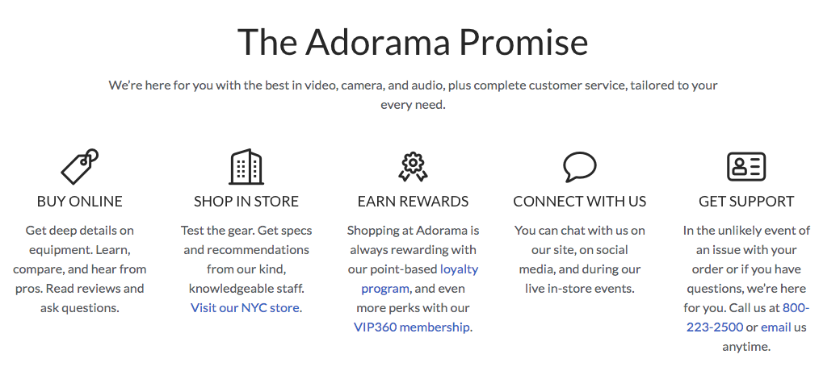

**Crutchfield**

Free 2 day shipping

Get expert help

46 years of enjoying the gear

Expert Advice

Free 2 day shipping

Free lifetime tech support

60 day returns

Car installation gear

In depth research

Articles, videos, and DIY tips

60 day price protection

eco friendly peanuts

trusted since 1974

**New Egg**

Shop with confidence

*"I have been coming back to Newegg for a long time now, and I am always impressed. Great sales, great selection, and the service is fantastic. I will continue to check here first" - Adwardo*

20M+ Top Selling Items

2.7K+ Popular Brands

4M+ Legit Customer Reviews

41M+ Number Of Customers

**Sweetwater**

